Chapter 9 – COM(+)
I often joke with students who sit through my security course at DevelopMentor that one of the objectives of the course is to produce 24 new developers who have some inkling of what COM security is all about. That generally gets a good laugh out of the crowd. Why is it that COM security seems so unapproachable to most developers? I'm convinced that the reason lies in all the chapters prior to this one. There's just an incredible amount of infrastructure underneath, and if one isn't familiar with the basic mechanisms that make up the Windows security model (such as logon sessions, window stations, network authentication, etc.), it's a pretty tough journey. But once you have a basic understanding of these mechanisms, COM security adds just a few more concepts and some extra details.
This chapter progresses from RPC to COM security, and then shows how COM+ configured components factor into the picture. It starts from the ground up because each layer builds on the previous layer, and understanding the historical progression of the technology is helpful in understanding why security in COM+ works the way it does. COM+ as implemented in Windows 2000 is simply an evolution of MTS, so most of the things I'll say about COM+ also apply to MTS. Rather than cluttering the text with "COM+/MTS," I'll simply use the term COM+ to refer to both systems, unless I'm specifically pointing out where they differ. Also, please note that this chapter covers COM+ as it was shipped with the operating system in February 2000.

The MSRPC Security Model
Understanding the concepts and model of RPC security is fundamental to understanding how COM security works. I originally planned to have a separate chapter on RPC security (because I felt that it would be useful on its own for any RPC programmers left out there), but I realized that most COM programmers would skip that chapter. So instead, I've incorporated the discussion of RPC security fundamentals into this chapter, and if you are here to understand COM security, I strongly recommend you don't skip this section.
MSRPC has an extremely simple security model that builds on the basic concepts of Windows security that were outlined in earlier chapters. MSRPC is designed to be network protocol agnostic; the client and server simply need to agree on a particular protocol, and MSRPC will load client- and server-side DLLs that know how to send RPC packets over TCP UDP, IPX, SPX, SMB, AppleTalk, or whatever. That's quite a feat. MSRPC is also designed to be authentication protocol agnostic. The client and server simply need to agree on a particular protocol, and MSRPC will load client- and server-side DLLs that know how to complete an authentication handshake using NTLM, Kerberos, SSL, SPNEGO, or whatever (see Figure 9.1). Chapter 7 discussed SSPI, which is what MSRPC uses to abstract itself from the differences among various authentication protocols.

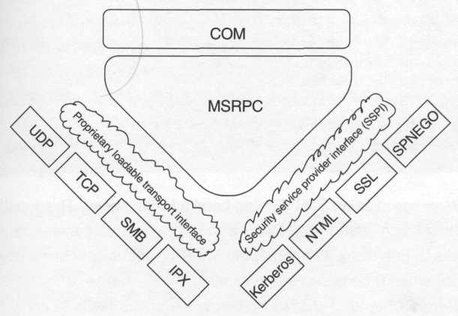
Figure 9.1 MSRPC's agnosticism

In MSRPC, it's possible for a server (Bob) to listen on multiple network protocols simultaneously. Bob typically indicates these protocols by making a call to RpcServerUseProtseq once for each protocol that he wants to support. When a client (Alice) wants to talk to the server, she must pick a single protocol and construct a binding handle that is annotated with that protocol's identifier. Any calls Alice makes to Bob using this binding handle will be made using the protocol she's specified (and as long as it's one of the protocols that Bob is listening on, things are good).
Similarly, it's possible for Bob to engage in authentication via a number of different authentication protocols. Bob indicates this list of protocols by making one or more calls to RpcServerRegisterAuthInfo. When Alice wants to contact Bob using a particular SSP, she must annotate her binding handle with this information before making any calls. As long as Alice chooses an SSP that Bob has registered, the SSPs will work together to authenticate Alice.
The Client Selects
Alice obtains a binding handle directed at a particular server by calling RpcBindingFromStringBinding, but before she can make any authenticated calls with that handle, she needs to annotate the handle with the authentication settings (including an SSP) that she wants to use. The function Alice calls to choose these settings is RpcBindingSetAuthInfoEx. This function is really important to understand, so each argument will be discussed (COM developers, pay attention here – you'll need this background later).

RPC_STATUS RpcBindingSetAuthlnfoEx(
RPC_BINDING_HANDLE Binding, // in
unsigned char PAPI *ServerPrincName, // in, optional
unsigned long AuthnLevel, // in
unsigned long AuthnSvc, // in
RPC_AUTH_IDENTITY_HANDLE AuthIdentity, // in, optional
unsigned long AuthzSvc, // in
RPC_SECURITY_QOS *SecurityQOS); // in

Binding specifies an RPC binding handle to the server. This function is all about setting some state in the binding so that when Alice makes remote procedure calls to Bob using its handle, the MSRPC runtime will know how to represent Alice when it comes to authentication.
Recall from Chapter 7 that in Kerberos, the client needs to know the principal name of the server in order to obtain a ticket to send to that server. This is what the ServerPrincName parameter to RpcBindingSetAuthlnfoEx is used for. Under Kerberos, authentication will fail unless the client specifies this principal name (in other words, Alice cannot pass NULL for ServerPrincName). If Alice doesn't know ahead of time what the server's identity is (and she doesn't care, she just wants to be able to get a ticket for the server), she can call RpcMgmtInqServerPrincName to obtain the principal name that the server has advertised (the server specifies this in his call to RpcServerRegisterAuthInfo).
The AuthnSvc parameter allows Alice to choose which SSP she wants to use. Any outgoing RPCs will use the protocol that the client chooses (if the server doesn't support that protocol, the RPC will fail). Here are the manifest constants that represent the mainstream SSPs:

#define RPC_C_AUTHN_GSS_NEGOTIATE 9
#define RPC_C_AUTHN_WINNT 10
#define RPC_C_AUTHN_GSS_SCHANNEL 14
#define RPC_C_AUTHN_GSS_KERBEROS 16

In this list, gss_negotiate represents SPNEGO, and winnt represents NTLM (the latter is the only one with built-in support on Windows NT 4; the others were introduced in Windows 2000).
AuthzSvc is a manifest constant that allows Alice to choose an authorization service. This is an artifact of MSRPC's DCE heritage, and unless you are using a third-party DCE security provider, you should specify rpc_c_authz_none for this parameter.
If Alice chooses the gss_negotiate authentication service, she can indicate an ordered list of authentication services that she prefers by passing a pointer to a sec_winnt_auth_identity_ex structure via the AuthIdentity parameter:

#define SECURITY_WIN32
#include <security.h>

typedef struct _SEC_WINNT_AUTH_IDENTITY_EX
{
unsigned long Version;
unsigned long Length;
LPTSTR User;
unsigned long UserLength;
LPTSTR Domain;
unsigned long DomainLength;
LPTSTR Password;
unsigned long PasswordLength;
unsigned long Flags;
LPTSTR PackageList;
unsigned long PackageListLength;
} SEC_WINNT_AUTH_IDENTITY_EX;

The list of authentication services is a single string with the comma-delimited names Kerberos, ntlm, and/or schannel. If all Alice wants to do is choose the packages used for negotiation, she should pass NULL for the User, Domain, and Password fields, and the SSP will obtain her network credentials automatically by looking at the security context of her thread (more on this later).
Whereas security package negotiation was introduced in Windows 2000, another feature that AuthIdentity can be used to enable is choosing an alternate set of credentials, which is supported on older platforms as well. Table 9.1 provides a few examples of values that Alice could specify for the User, Domain, and Password fields to dictate the client-side credentials to be used with the binding handle.

Table 9.1 Values for choosing credentials
User | Domain | Password | Result
0 | 0 | 0 | Uses the default credentials for the thread
«amy@foo.com» |  | «password» | Uses amy@foo.com
«amy» | «foo.com» | «password» | Uses amy@foo.com
 | «.» |  | Uses NULL session (NTLM only)

Here are the other details you should know if you plan on using this structure. The Version field should be set to sec_winnt_auth_identity_version, and the Length field should be set to the size of the structure. Because you can pass either Unicode or multibyte strings, the Flags field must indicate your choice via one of the following flags:

#define SEC_WINNT_AUTH_IDENTITY_ANSI 0x1
#define SEC_WINNT_AUTH_IDENTITY_UNICODE 0x2

A couple of other flags are listed in MSDN without adequate documentation:

#define SEC_WINNT_AUTH_IDENTITY_MARSHALLED 0x4
#define SEC_WINNT_AUTH_IDENTITY_ONLY 0x8

The first flag is used internally and (at least as of this writing) Microsoft doesn't provide documentation of the format for the expected "marshalled" structure (thus I mention this flag only for completeness). The second flag appears to be for use with non-Windows implementations of Kerberos, because it allows you to obtain a ticket without any authorization attributes, the structure of which is not defined by Kerberos. Just for kicks I tried using this flag and was treated to a NULL session on the server, which doesn't seem terribly useful.
Note that this data structure is not sent across the wire; rather, it is passed discreetly to the client-side SSP who uses it to determine how to authenticate outgoing requests (for example, which tickets to obtain and which password to use to answer an NTLM challenge).
Security Quality of Service
The information passed via SecurityQOS should be familiar if you happened to read Chapter 8. These are the security quality-of-service flags that provide extra information about the client's wishes:

typedef struct _RPC_SECURITY_QOS
{
unsigned long Version;
unsigned long Capabilities;
unsigned long IdentityTracking;
unsigned long ImpersonationType;
} RPC_SECURITY_QOS;

If you want proof of the server's identity, set the rpc_c_qos_capabilities _mutual_auth flag in the Capabilities field of this structure. This causes the RPC runtime to request mutual authentication; in the case of Kerberos, this means that the KRB_AP_REQ message will contain an option indicating that the server should prove knowledge of the session key in the ticket (as discussed in Chapter 7) and reply with a KRB_AP_REP message. The end result is that if Alice requests mutual authentication and her first call to the server succeeds, she's assured that the server is indeed running under the credentials she specified via ServerPrincName. If the server is running as some other principal, Alice's calls to the server will fail. (In my experience, the error code has always been rpc_s_sec_pkg_error: "A security package specific error occurred.")
Interestingly enough, if you're using SPNEGO and you pass NULL for ServerPrincName, MSRPC will choose NTLM over Kerberos. What it boils down to is this: as a client, if you know the server principal name (or think you know), you should always specify it explicitly if you want to have any chance of using Kerberos.
The IdentityTracking field determines when (chronologically) the MSRPC runtime should select the client's default credentials (in other words, the credentials to be used when the client passes NULL for AuthIdentity), The two possible settings for this field are as follows:

RPC_C_QOS_IDENTITY_STATIC
RPC_C_QOS_IDENTITY_DYNAMIC

The first option (the default) says that the MSRPC runtime will only select client-side credentials when the client calls RpcBindingSetAuthInfo(Ex), and will continue to use those same credentials for that binding handle until another call to RpcBindingSetAuthInfo(Ex) causes a different set of credentials to be cached. Here's an example to illustrate:

- A thread in a process hosted in Alice's logon session calls RpcBindingSetAuthInfoEx (RpcBSAIEx).
- All RPCs using this binding handle now use Alice's credentials.
- The thread now begins impersonating Mary and makes an RPC using this binding handle; the outgoing call still uses Alice's credentials.
- While still impersonating Mary, the thread calls RpcBSAIEx again on the same binding handle. Now outgoing calls through this binding handle use Mary's credentials.
- The thread stops impersonating Mary.
- All RPCs using the binding handle still use Mary's credentials.
- The thread (no longer impersonating) calls RpcBSAIEx one more time. All new RPCs using this binding handle use Alice's credentials once more.

As you can see by this example, the binding handle holds a "sticky" reference to the client's network credentials (if you recall from the discussion of SSPI in Chapter 7, this is physically a client-side SSPI credential handle obtained by calling AcquireCredentialsHandle). Since static (sticky) tracking is used by default, you should be very aware of your thread's security context when you call RpcBindingSetAuthInfo(Ex), unless you are passing explicit credentials via pAuthldentity.
The second tracking option (dynamic) says that MSRPC should gather the client's credentials at each outgoing call. Unlike the file server (where dynamic tracking only works locally), MSRPC happily implements dynamic tracking over the wire and thus reauthenticates at the next RPC if your thread's security context has changed since your last RPC.
All this talk about identity tracking is only interesting if the thread making outgoing RPCs happens to also use impersonation occasionally. The dynamic tracking option makes MSRPC work very much like the operating system works locally, and is considerably more intuitive to most people than static tracking.
ImpersonationType indicates the amount of trust the client places in the server via the same four impersonation levels that were discussed in Chapter 4; the manifest constants are different, but the concept remains the same. If Bob impersonates Alice, the token he gets will have the impersonation level that Alice specifies, so this limits what Bob can do with Alice's credentials:

#define RPC_C_IMP_LEVEL_ANONYMOUS 1
#define RPC_C_IMP_LEVEL_IDENTIFY 2
#define RPC_C_IMP_LEVEL_IMPERSONATE 3
#define RPC_C_IMP_LEVEL_DELEGATE 4

MSRPC supports the anonymous level over the local interprocess communication transport (ncalrpc) only. For other transports, it silently promotes this level to identify.
One final setting that's not shown here is the rather esoteric "effective-only" flag that may be specified in the binding string itself. This is equivalent to the security_effective_only flag discussed in Chapter 8, and again, it only has an effect if the client and server are on the same machine and are using the local interprocess communication transport. For instance, the binding string

"ncalrpc[Security=identification static true]"

indicates not only that the impersonation level is identification and the identity-tracking setting is static, but also that only the enabled privileges in the client's token should be present in the token seen by the server. Don't be surprised if you see this behavior for local COM servers as well, because effective-only is the default setting and COM provides no facility for changing this. Because this feature only works locally, you won't see this behavior across the wire, which is a good thing because privileges are granted on a per-machine basis and thus the privileges that happen to be present in Alice's token on AlicesMachine may be completely different from the privileges that reside in Alice's token on BobsMachine.
Authentication Levels
The only parameter to RpcBindingSetAuthInfoEx that has not yet been covered is AuthnLevel. This parameter allows Alice to choose exactly how much protection she desires from her SSP. Recall from Chapter 7 that during an authentication exchange, Alice and Bob each discover a session key that they can use to sign or seal packets that they send to one another. AuthnLevel allows Alice to control exactly how this session key should be used:

#define RPC_C_AUTHN_LEVEL_NONE 1
#define RPC_C_AUTHN_LEVEL_CONNECT 2
#define RPC_C_AUTHN_LEVEL_CALL 3
#define RPC_C_AUTHN_LEVEL_PKT 4
#define RPC_C_AUTHN_LEVEL_PKT_INTEGRITY 5
#define RPC_C_AUTHN_LEVEL_PKT_PRIVACY 6

These constants are purposely arranged in order of increasing security. If Alice cranks this level all the way up to pkt_privacy, the entire message (headers and payload) will be signed and the payload will be sealed with the session key. Because AuthnLevel provides equal protection for the request and response packets, both [in] and [out] parameters are protected. What does Bob know when he receives a call at this authentication level? He knows that the parameters were hidden from eavesdroppers, and because the packet is signed with the session key, he knows that it came from Alice and that it hasn't been tampered with. (If tampering is detected, the MSRPC runtime fails the call at the door and Bob's procedure isn't invoked at all.)
If Alice doesn't require confidentiality, she might instead choose pkt_integrity to save some CPU cycles. Here, the SSP signs the entire packet contents with the session key (forming a MAC), but the payload is not encrypted. Thus MSRPC can still detect any tampering with the payload or headers and can guarantee to Bob that every last fragment of the RPC request was actually sent by Alice (because she is the only other party who knows the session key). If MSRPC cannot verify the MAC, the call will be rejected immediately with an error.
To avoid signing the entire payload, the authentication level pkt indicates that only the headers should be signed. This saves even more CPU cycles, at the risk of allowing tampering with the payload to go unnoticed.
To avoid signing each fragment of a large RPC request or response, the authentication level call indicates that only the headers of the first fragment should be signed. This is a rather obscure setting, and is in fact not implemented by any of the mainstream SSPs. If Alice chooses this level, it'll be silently promoted to pkt.
To avoid signing or sealing anything at all, Alice can choose authentication level connect. This indicates that at connection time (in other words, at TCP connection establishment, SMB session establishment, etc.), the normal authentication handshake should take place, resulting in the exchange of a session key, as usual. However, the session key is not to be used at all for the remainder of the connection. This saves even more CPU cycles, but it also leaves Alice hoping that a determined attacker isn't smart enough to realize that he or she can simply hijack Alice's connection and start sending packets to Bob (or intercepting Alice's packets, changing them, and then sending them to Bob). Bob won't know that these packets are coming from a bad guy. He won't really know the true origin of any packets arriving via this connection, nor will Alice know the true origin of the response. Clearly this level only will work if Alice chooses to make RPC calls over a connection-oriented transport such as TCP or SMB. If Alice chooses a datagram transport (for instance, UDP), connect is silently promoted to pkt.
The last level is none, which indicates that no authentication handshake should occur at all. If the client chooses this level, none of the other parameters to RpcBindingSetAuthnInfoEx have any meaning, and so they will be ignored (note that if you choose this authentication level you must also set the authentication service to rpc_c_authn_none). This is the default setting in RPC; if Alice forgets to call RpcBindingSetAuthnInfoEx on her binding handle, no authentication handshake will be performed at all, and thus no network logon session (not even a NULL session) will be established on Bob's machine as a result of RPCs coming from Alice; thus, Bob won't be able to get a token to discover who the client is.
As you can see, RpcBindingSetAuthInfoEx allows Alice to specify boatloads of configuration information so that her SSP knows how to represent her on the wire. In summary, Alice can choose which authentication protocol to use (AuthnSvc), how much protection she wants (AuthnLevel), a name to use in order to verify the server's identity (ServerPrincName), whether she wants to use an alternate set of credentials (AuthIdentity), and how much she trusts the server to impersonate her (SecurityQOS.ImpersonationType). All these settings are chosen at Alice's discretion.
Solving Race Conditions
As a client, you can call RpcBindingSetAuthInfoEx any time you want to change the security settings on a binding handle. MSRPC will simply reauthenticate the next time you make a method call using that binding handle. This means, for example, that you can dynamically switch between pkt_privacy and pkt_integrity so that you only pay the price for encryption on the RPCs that send or receive truly sensitive data. In fact, sometimes it's convenient to have two separate binding handles that point to the same server endpoint but differ in security settings. When you make calls using the first handle, they will go out at pkt_integrity; when you make calls using the second handle, they will go out at pkt_privacy.
This technique is traditionally used to solve race conditions in which multiple threads are competing for a single binding handle. By giving each thread its own binding handle, that thread has autonomy to adjust the authentication settings at any time without introducing race conditions. MSRPC provides a couple of functions to make this easy:

RpcBindingCopy(
RPC_BINDING_HANDLE SourceBinding,
RPC_BINDING_HANDLE* DestinationBinding);

RPC_STATUS RPC_ENTRY RpcBindingInqAuthInfoEx(
RPC_BINDING_HANDLE Binding,
RPC_CHAR PAPI* ServerPrincName,
unsigned long PAPI* AuthnLevel,
unsigned long PAPI* AuthnSvc,
RPC_AUTH_IDENTITY_HANDLE PAPI* AuthIdentity,
unsigned long PAPI* AuthzSvc,
unsigned long RpcQosVersion,
RPC_SECURITY_QOS* SecurityQos);

By making a copy of an existing binding handle via RpcBindingCopy, and then asking for the current authentication settings via RpcBindingInqAuthInfoEx, the thread can then adjust only the settings it wants to tweak (most often this is used to change the authentication level, as suggested earlier).
What If Authentication Fails?
Imagine what would happen if Alice chooses an authentication level of pkt_privacy and makes an RPC to Bob, requesting sensitive medical records. First of all, if she's using Kerberos, her SSP will verify Bob's identity assuming she's requested mutual authentication. Second, she is going to expect that those medical records will be encrypted so nobody can discover their contents as they travel across the wire; that's confidential information for Alice.
What are some reasons why the authentication handshake Alice requested might fail? In practice, the most common reason is that there is no path of trust from Bob's authority to Alice's authority, which means that there is no way to allow Alice and Bob to securely exchange a session key. Without a session key, Bob cannot prove (via Kerberos, at least) his identity to Alice. Without a session key, Bob also cannot encrypt those medical records to send back to Alice. None of Alice's requirements can be met if authentication fails. So the question is, what should MSRPC do in this case? Allow the call to succeed? Or fail the call immediately?
The answer is that the call fails (as you probably expected it would). Note that the reason it failed is because Alice and Bob's SSPs could not make Alice happy; it has nothing to do with what Bob wants. If Alice requests authentication, and authentication fails, the call will always fail. The error code you might expect in this case would be something like "Gee, sorry Alice, Bob's happy to accept anonymous callers, but since you requested authentication protection and Bob can't make it happen, we had to fail the call (if you want, you may try again without authentication and the call will likely succeed)." However, to avoid giving attackers any information about a failure that would help them adjust their penetration strategy, the call simply fails with error_access_DENIED.
This is a fantastic example of why it can be difficult to debug security-related errors: the system is designed to make this hard for an outsider. But if you've been paying attention, you probably already know exactly how to figure out what went wrong in this case. As a good guy, you (or an administrator that you can contact) will have access to the server and can enable auditing of logon and logoff events (I can't recommend this enough). By looking in the audit log, you'll see the reason the SSP gave for failing Alice's authentication request (probably "bad user name or password," but it could also be something as silly as "password needs to be changed at first logon"). You can also use Alice's Kerberos ticket cache (discussed in Chapter 7) to find more clues. The more you know about how authentication works, the more quickly you'll be able to diagnose problems in the field.
The Server Detects
Yes, there's a little rhyme that weaves its way through this chapter: the client selects, and the server detects. Remember this rhyme and you'll be well on your way to understanding RPC and COM security.
Alice can select any authentication protocol and any authentication level she likes (even none) and make calls to Bob. In MSRPC, Bob receives all incoming authenticated calls (assuming Alice's requests can be satisfied by the SSPs). What might surprise you at first is that in MSRPC, Bob receives all incoming anonymous calls as well (where the caller chose not to use authentication at all). It's up to Bob to detect the settings chosen by the client and act accordingly (a highly secure server would likely reject all anonymous calls, for instance).
When one of Bob's procedures is invoked by the MSRPC runtime on Alice's behalf, Bob takes his server-side binding handle and passes it to RpcBindingInqAuthClient. (Technically, ClientBinding is an Optional parameter; if you pass NULL, the MSRPC runtime assumes you want information about the current caller for the thread.)

RPC_STATUS RpcBindingInqAuthClient(
RPC_BINDING_HANDLE ClientBinding, // in, optional
RPC_AUTHZ_HANDLE* Privs, // out, optional
unsigned char** ServerPrincName, // out, optional
unsigned long* AuthnLevel, // out, optional
unsigned long* AuthnSvc, // out, optional
unsigned long* AuthzSvc); // out, optional

First note that this function will fail if the client chose not to authenticate at all (either by specifying an authentication level of none or by not calling RpcBindingSetAuthInfoEx). Bob should always be careful to check for this condition, because it indicates an anonymous caller.
Bob can pass NULL for any of the [out] parameters that he's not interested in. (For instance, AuthzSvc isn't interesting to people not using DCE security, and AuthnSvc and ServerPrincipalName aren't going to be surprising because they will come from the set Bob registered earlier via RpcServerRegisterAuthlnfo.)
AuthnLevel indicates the level of protection selected by the client (and thus the level being used for the duration of this remote procedure call). This is one of the first things Bob is going to care about. Is the client-selected level satisfactory to him? (Bob cannot change the level at this point, but he can choose to return an error code and ignore the client's request if he's not satisfied with the client's choice.) Bob might even look at the [in] parameters Alice passed in her request and determine that because she's asking for really sensitive information, he'll fail the call unless she chose pkt_privacy; for less sensitive requests, Bob may be satisfied with pkt_integrity. The choice is left entirely up to Bob; MSRPC makes no judgments here.
This explanation should make it clear why MSRPC allows anonymous callers through by default: it assumes that the server is smart enough to reject anonymous calls to sensitive procedures.
Privs is an interesting parameter that might convince Bob to pay attention to the AuthnSvc parameter as well, since Privs basically allows him to get a pointer to some SSP-specific data structure designed to be used for making authorization decisions (hence the name). For the NTLM and Kerberos SSPs, this pointer will refer to the client principal name in Authority\Principal format. If all you need is the client's name, this is the cheapest way to get it, because this information is always sent across the wire in an NTLM or Kerberos exchange and is sitting there in the server-side SSP's security context, waiting for you to ask for it.
If Bob needs more information than is provided by RpcBindingInqAuth client, he can impersonate Alice and open her token (via OpenThread Token, as discussed in Chapter 4).

RPC_STATUS RpcImpersonateClient(
RPC_BINDING_HANDLE BindingHandle); // in, optional
RPC_STATUS RpcRevertToSelf();

This of course assumes that Alice hasn't chosen an impersonation level of RPC_C_IMP_LEVEL_ANONYMOUS (if she has, OpenThreadToken will fail).
RPC Security Wrapup
That's all there is to it. RPC security is fundamentally a very simple model, exposed via a very small set of functions. The client selects an SSP and a group of authentication settings, and MSRPC uses those settings to authenticate (or not) with the server. As long as the client has chosen an SSP that the server is happy with (or has made an anonymous, unauthenticated call), authentication will proceed according to the client's wishes. If authentication fails, the call fails. If authentication succeeds (or if it's an anonymous call), the server detects the client's chosen settings and reacts appropriately. MSRPC doesn't attempt to provide a default access control policy; the server receives all anonymous and successfully authenticated calls and makes its own choices.
As a result of this simplicity, RPC security is quite straightforward to use and debug in the field. To wrap up this section, I've provided an example of an RPC client and server using the functions described previously. Here's the client code:

long sum = _addViaRPC (2 , 2, L"ncacn_ip_tcp:BobsMachine", L"bob@foo.com");

long _addViaRPC(long a, long b,
wchar_t* pszBindingString,
wchar_t* pszExpectedServerPrincipal)
{
// get a binding handle to the server
RPC_BINDING_HANDLE h;
RPC_STATUS s = RpcBindingFromStringBinding(pszBindingString, &h);

if (s) _err(L"RpcBindingFromStringBinding", s);

// select authn settings on the binding handle
RPC_SECURITY_QOS sqos = {

RPC_C_SECURITY_QOS_VERSION,
RPC_C_QOS_CAPABILITIES_MUTUAL_AUTH,
RPC_C_QOS_IDENTITY_STATIC,
RPC_C_IMP_LEVEL_IDENTIFY};

s = RpcBindingSetAuthInfoEx(h,
pszExpectedServerPrincipal,

RPC_C_AUTHN_LEVEL_PKT_INTEGRITY,

RPC_C_AUTHN_GSS_KERBEROS,
0,
RPC_C_AUTHZ_NONE,
&sqos);

if (s) _err(L"RpcBindingSetAuthlnfoEx", s);
long sum = 0;
__try
{
sum = Add(h, a, b); // here's the actual RPC
}
__except(EXCEPTION_EXECUTE_HANDLER)
{
_err(L"RPC", GetExceptionCode());
}
RpcBindingFree(&h);
return sum;
}

Here's the implementation of Add in the server. Note that the server verifies the client's authentication level (only after carefully checking the error code returned from RpcBindingInqAuthClient):

long Add(RPC_BINDING_HANDLE h, long a, long b)
{
// server detects the client's authn settings
RPC_AUTHZ_HANDLE hPrivs;
DWORD nAuthnLevel;
RPC_STATUS s = RpcBindinglnqAuthClient(h, &hPrivs, 0,
&nAuthnLevel, 0, 0);

// don't allow anonymous callers to slip through
if (s) RpcRaiseException(ERROR_ACCESS_DENIED);

// make sure we're happy with the caller's authn level
if (nAuthnLevel < RPC_C_AUTHN_LEVEL_PKT_INTEGRITY)
RpcRaiseException(ERROR_ACCESS_DENIED);

// here's a really low-tech auditing mechanism ;-)
wprintf(L"Add invoked by %s\n", (wchar_t*)hPrivs);
return a + b;
}

Here's the code that the server calls from main to service RPC requests. Most of it is just boilerplate RPC, but notice the first two API calls: the first selects a network transport; the second selects a network authentication protocol (Kerberos).

void _listenForRPCRequests()
{
// choose a network transport: TCP
RpcServerUseProtseq(L"ncacn_ip_tcp",
RPC_C_PROTSEQ_MAX_REQS_DEFAULT, 0);

// choose a network authentication protocol: Kerberos
RpcServerRegisterAuthlnfo(L"bob@foo.com",
RPC_C_AUTHN_GSS_KERBEROS, 0, 0);

// see which TCP port we were allocated
RPC_BINDING_VECTOR* pbv;
RpcServerInqBindings(&pbv);

// register protseq/port/uuid with the endpoint mapper
RpcEpRegister(RpcCalc_vl_0_s_ifspec, pbv, 0, 0);

// register our RpcCalc interface with the RPC runtime
RpcServerRegisterIf(RpcCalc_vl_0_s_ifspec, 0, 0);

// turn on the fire hose!
RpcServerListen(0, RPC_C_LISTEN_MAX_CALLS_DEFAULT, FALSE);
}

The COM Security Model
With a basic understanding of how RPC security works, you'll be surprised how easy COM security can be. The first thing you must understand is how a COM proxy is built (see Figure 9.2). Note that each interface proxy holds a pointer to a channel object. Each interface proxy is responsible for marshaling stack frames to and from transmission buffers provided by the channel; the interface proxy itself could care less about security or even where the call will be dispatched. The channel ultimately wraps the services provided by MSRPC, and you can probably guess what each of those channel objects really holds under the sheets: an RPC binding handle.

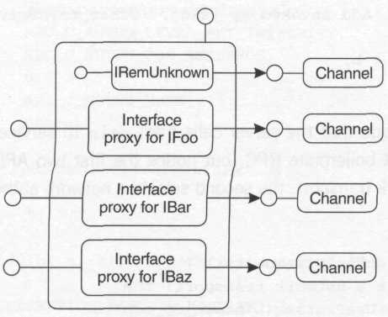
Figure 9.2 Anatomy of a COM proxy
The Client Selects
Remember the RPC security rhyme? It's the same rhyme in COM, except that the binding handles you're configuring are buried down in the channel objects shown in Figure 9.2. The COM interface you use to configure these binding handles is known as IClientSecurity, and it should look remarkably familiar considering what you've seen so far.

[local, ...]
interface IClientSecurity : IUnknown
{
HRESULT QueryBlanket(
[in] IUnknown* pProxy,
[out] DWORD* pAuthnSvc,
[out] DWORD* pAuthzSvc,
[out] OLECHAR** pServerPrincName,
[out] DWORD* pAuthnLevel,
[out] DWORD* pImpLevel,
[out] void** pAuthInfo,
[out] DWORD* pCapabilites);

HRESULT SetBlanket(
[in] IUnknown* pProxy,
[in] DWORD dwAuthnSvc,
[in] DWORD dwAuthzSvc,
[in] OLECHAR* pServerPrincName,
[in] DWORD dwAuthnLevel,
[in] DWORD dwImpLevel,
[in] void* pAuthInfo,
[in] DWORD dwCapabilities);

HRESULT CopyProxy(
[in] IUnknown* pProxy,
[out] IUnknown** ppCopy);
}

First of all, notice that this interface is marked [local]. This means it's never remoted: this interface is implemented by the proxy manager directly (see Figure 9.3) and is simply used to adjust the settings on the binding handles that COM has squirreled away down in the channel. Apparently somebody on the COM team had a sense of humor: instead of configuring authentication settings as we do in RPC, we configure a security blanket in COM to do the same thing.

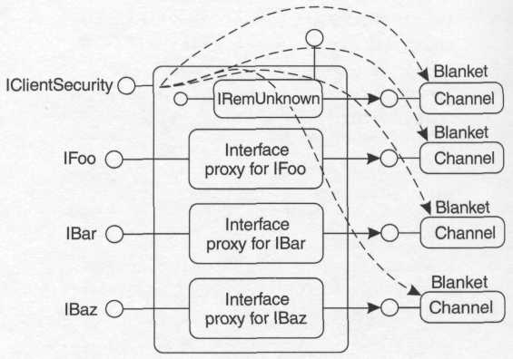
Figure 9.3 Security blankets in a proxy

Take a look at the three methods of IClientSecurity, and notice the striking resemblance to three MSRPC APIs I've already described:

COM
ICS::SetBlanket
ICS::CopyProxy
ICS::QueryBlanket

RPC
RpcBindingSetAuthInfoEx
RpcBindingCopy
RpcBindingInqAuthInfoEx

Whereas the RPC APIs expect to operate on binding handles, IClientSecurity expects to operate on interface pointers to proxies. At the end of the day, however, it's really just the same old RPC security model. Here's an example:

void _sendASecretToBob(ISecret* pSecret)
{
IClientSecurity* pcs;
pSecret->QueryInterface(IID_IClientSecurity, (void**)&pcs);

pcs->SetBlanket(pSecret,
RPC_C_AUTHN_GSS_KERBEROS, RPC_C_AUTHZ_NONE,
L"bob@foo.com",
RPC_C_AUTHN_LEVEL_PKT_PRIVACY,
RPC_C_IMP_LEVEL_IDENTIFY,
0, 0);

// assuming we can authenticate with Bob, the call
// will be encrypted using a Kerberos session key
pSecret->HeresASecret(
L"The answer to life, "
L"the universe, "
L"and everything is 42.");

pcs->Release();
}

This code tells the proxy manager that we want to tweak the authentication settings of the binding handle associated with pSecret to use Kerberos authentication with encryption and so forth. Just as with RPC, if the system can't make the client happy (for instance, if authentication fails), the call will fail with e_accessdenied. This happens regardless of what the server wants, because we always have to satisfy the client's request for authentication before we worry about making the server happy. If you want to control the settings used in the proxy manager's internal calls to IRemUnknown, you must pass the non-delegating unknown as the first parameter.
There are three shortcuts that make SetBlanket and friends a bit easier to call (each shortcut API takes the same parameters as its respective cousin in IClientSecurity):

HRESULT CoSetProxyBlanket(/* same as SetBlanket */);
HRESULT CoQueryProxyBlanket(/* same as QueryBlanket */);
HRESULT CoCopyProxy(/* same as CopyProxy */);

This saves you from having to call Querylnterface for IClientSecurity, in case you felt that was too much of a hassle. Here's an example using the shortcut:

void _sendASecretToBob2(ISecret* pSecret)
{
CoSetProxyBlanket(pSecret,
RPC_C_AUTHN_GSS_KERBEROS, RPC_C_AUTHZ_NONE, L"bob@foo.com",
RPC_C_AUTHN_LEVEL_PKT_PRIVACY, RPC_C_IMP_LEVEL_IDENTIFY, 0, 0);

// assuming we can authenticate with Bob, the call
// will be encrypted using a Kerberos session key
pSecret->HeresASecret(L"But what is the question?");
}

Besides using interface pointers instead of binding handles in IClientSecurity, note that the rpc_security_qos data structure has been unfolded into two top-level parameters: dwImpLevel and dwCapabilities. The impersonation level constants are the same ones used in RPC. Here are the flags that you can pass via dwCapabilities:

// simplified excerpt from objidl.idl
EOAC_MUTUAL_AUTH = 0x0001
EOAC_STATIC_CLOAKING = 0x0020
EOAC_DYNAMIC_CLOAKING = 0x0040
EOAC_DEFAULT = 0x0800

The first flag should look familiar: It's a request for mutual authentication, but COM ignores this flag and always requests mutual authentication on your behalf if the SSP in use supports it. I'll talk about eoac_default a bit later. For now, let's talk about a Windows 2000 feature called cloaking.
Cloaking
Cloaking is just a fancy-schmancy new term for something we've had all along in named pipes and RPC: control over identity tracking. In Windows NT 4, the one and only identity-tracking mode was that of the default in RPC: static, or sticky, tracking. Whenever you'd call SetBlanket, the blanket would cache the current identity of the calling thread. (If Bob's thread was impersonating Alice when he called SetBlanket, the blanket took on Alice's identity until he called SetBlanket again.)
Windows 2000 exposes the dynamic identity-tracking model as well (it's not clear why this wasn't an option in Windows NT 4, since MSRPC has supported this model for years). What's interesting is that Windows 2000 added a third option that RPC doesn't intrinsically support, and made it the default. I'll call this the "ignore the thread token" tracking option, because it does just that: COM completely ignores thread tokens when determining the credentials to use for the outgoing call; it always uses the process token to pick up credentials for the outgoing call. Figure 9.4 shows the differences among the three models.
Here's how the cloaking constants map onto the behaviors I've described above:

EOAC_STATIC_CLOAKING static (sticky) identity tracking
EOAC_DYNAMIC_CLOAKING Dynamic identity tracking
0x0000 "Ignore the thread token" identity tracking

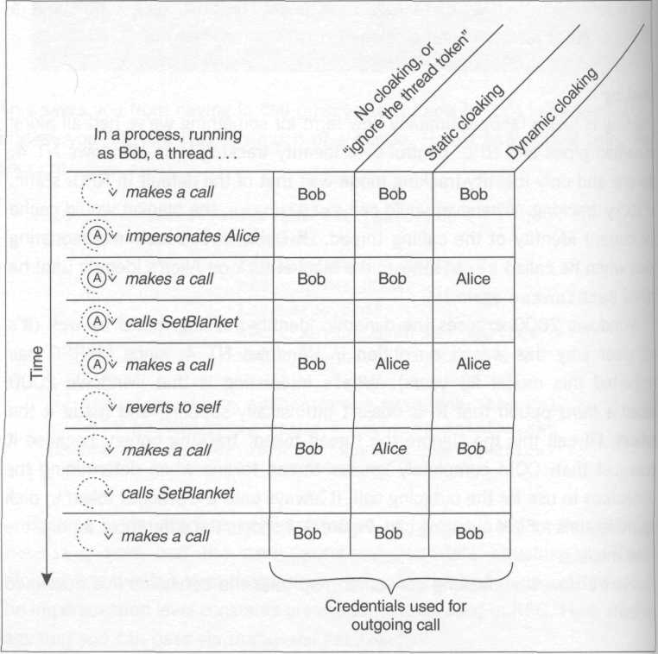
Figure 9.4 Cloaking in action
CopyProxy (Considered Useless)
Remember RpcBindingCopy? That function was traditionally used to solve race conditions between threads that were sharing binding handles. If one thread wanted to temporarily elevate the authentication level on a handle, it could make a clone of the handle and make the change on the clone to avoid interfering with any other threads using the original handle. There is a similar function for COM clients called CopyProxy that results in the same behavior.

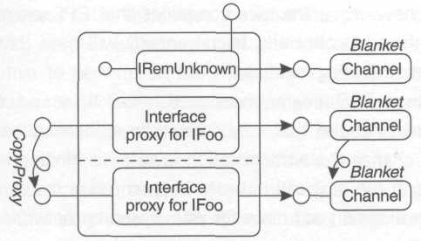
Figure 9.5 The effect of CopyProxy

The resulting proxy looks rather strange (see Figure 9.5) because the result is a second interface pointer (attached to the same proxy manager) that implements the same interface as the first. But deep down in the guts of the channel, it has its own private binding handle, and so any blanket settings you apply to it won't have any affect on the original interface pointer.
In COM, you shouldn't ever need to worry about calling CopyProxy to avoid race conditions between threads, because if you're a savvy COM(+) developer, you'll realize that you should never share interface pointers directly between threads unless they point directly to objects that you know are context neutral (such as the IStream pointer returned from CoMarshaInterThreadInterfaceInStream). Proxies are not considered context neutral by any stretch of the imagination; the interceptors set up between the proxy and stub are based on the differences between the client and object's contexts, and using one proxy from another context results in (at best) an error or (at worst) completely undefined behavior.
If you are already being careful to marshal interface pointers between threads, you'll never have the race conditions that RPC programmers suffer, because each thread (technically, each context) will have its own proxy and thus its own set of binding handles.
Another reason RPC programmers used to call RpcBindingCopy was to have two different handles that only differed by authentication level, because each time you change the authentication level on a binding handle you'll be reauthenticated at the next call in order to synchronize the client- and server-side SSPs. I have some good news for you: based on network traces I've performed, it appears as though each channel has the capacity to have multiple binding handles without any assistance from you; if the authentication level on a particular interface pointer starts out at pkt_integrity, say, and then you adjust it to pkt_privacy by calling SetBlanket, MSRPC will simply re-authenticate you in order to synchronize the client- and server-side SSPs. However, since the channel has cached the original (pkt_integrity) binding handle, when you readjust the blanket back to pkt_integrity, the system simply starts using the old binding handle again (you can switch back and forth between these two levels all you want at this point without any further network overhead). This means that you don't need to use CopyProxy to optimize overlapped calls at different authentication levels – just adjust the authentication level whenever you feel like it, and COM will do all the binding handle caching behind the scenes to make sure things are as efficient as possible. (This optimization is not documented, so caveat emptor.)
I can't think of any really compelling reason to call CopyProxy, but if you find it absolutely necessary, one thing to watch out for is that the cloned interface pointers it creates are not visible via QueryInterface. So if you write a helper component in C++ that adjusts the blanket settings for a VB or scripting programmer (IClientSecurity isn't very friendly to either of those environments), you should not call CopyProxy, then configure the copy and hand the copy back to the caller. Virtually all these higher-level environments will automatically perform a QueryInterface on any interface pointer they obtain, which means the original caller will never see the fine work that you've done because they'll end up using the original pointer they gave you in the first place.
NTLM and Proxies to Local Objects
For local cross-process calls, COM uses the local interprocess communication transport (always), coupled with the NTLM protocol, which in this particular case doesn't bother to perform an SSPI authentication handshake at all, the premise being that once Alice has a logon session on AlicesMachine, she should be able to use that same logon session to talk to any resources on that machine, including COM servers (recall that an SSPI handshake results in a new network logon session for the client). Instead of establishing a new logon session for Alice, the NTLM SSP simply duplicates Alice's token (using the impersonation level specified in the blanket) and gives it to the server-side SSP, where it is picked up by the channel and used in access checks (and potentially impersonation if the server chooses to impersonate).
This affects your life in a very profound way. For one thing, SetBlanket is not nearly as useful for proxies to local (as opposed to remote) objects, because it's designed to specify settings for an SSP to use in an authentication handshake (alternate credentials, authentication levels, and so on). COM is not going to perform an authentication handshake in this case, so most of the parameters to SetBlanket are simply ignored (leading to much confusion and gnashing of teeth by developers who aren't aware of this special case).
Because COM uses the local interprocess communication transport in this example, the payload is never visible to network adapters or to any bad guys on the network. Thus while encryption is not used for confidentiality, the authentication level will still be fixed at rpc_c_authn_level_pkt_privacy, which will make any local server happy.
The two settings that Alice can control here are the impersonation level and the identity-tracking policy (cloaking), which allows Alice to choose which token gets duplicated: her process token or potentially a thread token if she happens to be impersonating.
Alice should choose the impersonation level she uses in calls to local servers with caution. If Alice makes a call to a local server (Bob), Bob can impersonate her, and his thread will now be running in her logon session. If Alice's logon session has network credentials (which is natural for most logon sessions, except potentially a network logon session), Bob will be able to use those credentials if Alice has specified an impersonation level of rpc_c_imp_level_impersonate or higher. (If this surprises you, see the section in Chapter 4 entitled Trust.) The SecurityImpersonation authentication level (as of this writing) does not prevent a local server from accessing the client's network credentials as one might conclude based on its documentation. To protect against this, Alice can use rpc_c_imp_level_identify; however, be aware that this will prevent Bob from obtaining even local resources on Alice's behalf.
One final note regarding local COM communications: one option that is enabled by default on every RPC binding handle that uses the local interprocess communication transport is the "effective-only" mode discussed earlier, which means the only privileges that will be present in the token obtained by the server will be those that were enabled at the time the client made a call. This surprises almost everyone who impersonates a local client and tries to enable privileges. If Alice wants Bob (a local COM server) to be able to use one other privileges while he's impersonating her, she'll have to enable that privilege in her token before making the call into Bob.
I thought that I could be clever and get around these ugly limitations by forcing my client to use Kerberos for local calls. However, for some reason, as of this writing MSRPC doesn't allow Kerberos to run over the local interprocess communication transport (which COM always uses for local out-of-process communication), and thus if you try to force Kerberos via SetBlanket, you'll get an error code of rpc_s_unknown_authn_service. So it goes.
The Server Detects
When an incoming call arrives, the server can discover information about the caller's authentication settings, just as with RPC:

[local, ...]
interface IServerSecurity : IUnknown
{
HRESULT QueryBlanket(
[out] DWORD* pAuthnSvc,
[out] DWORD* pAuthzSvc,
[out] OLECHAR** pServerPrincName,
[out] DWORD* pAuthnLevel,
[out] DWORD* pImpLevel, // reserved, mbz
[out] void** pPrivs,
[in,out] DWORD* pCapabilities );

HRESULT ImpersonateClient();
HRESULT RevertToSelf();
BOOL IsImpersonating();
}

HRESULT CoGetCallContext(REFIID riid, void **ppInterface);
HRESULT CoQueryClientBlanket(/* same as above */);
HRESULT CoImpersonateClient();
HRESULT CoRevertToSelf(};

To get a pointer to IServerSecurity, the object must (during a method call) reach up and ask COM for this information by calling CoGetCallContext (calling this function outside the scope of a method call is meaningless and results in an error). Once again, there are shortcuts provided that save you a call to CoGetCallContext.
Notice the similarities to RPC security:

COM
ISS::QueryClientBlanket
ISS::ImpersonateClient
ISS::RevertToSelf
RPC
RpcBindingInqAuthClient
RpcImpersonateClient
RpcRevertToSelf

There's really nothing different here. The explanations provided in the section on RPC security hold here equally well; the only difference is that you are using a COM interface to get this information as opposed to making an RPC API call.
What I've not yet addressed is how a server selects the SSPs it wants to use. Instead of making several calls to RpcServerRegisterAuthlnfo, once per SSP, COM provides a single API that takes a counted array of data structures that describe the requested SSP and its parameters (the two relevant parameters are highlighted below):

typedef struct tagSOLE_AUTHENTICATION_SERVICE
{
DWORD dwAuthnSvc;
DWORD dwAuthzSvc;
OLECHAR* pPrincipalName; // advertised name
HRESULT hr;
} SOLE_AUTHENTICATION_SERVICE;

WINOLEAPI CoInitializeSecurity(
PSECURITY_DESCRIPTOR pSecDesc,
LONG cAuthSvc,
SOLE_AUTHENTICATION_SERVICE *asAuthSvc,
void *pReservedl,
DWORD dwAuthnLevel,
DWORD dwImpLevel,
void *pAuthList,
DWORD dwCapabilities,
void *pReserved3);

While the details of the other arguments to CoInitializeSecurity will be covered shortly, for now, here's a direct translation of the earlier RPC example in COM. The programming model here is the same: The client selects authentication settings, and the server detects them. Here's the client code (note that I used the shortcut CoSetProxyBlanket to save some typing):

long sum = _addViaCOM(2, 2, pCalc, L"bob@foo.com");

long _addViaCOM(long a, long b, ICalc* pCalc,
wchar_t* pszExpectedServerPrincipal)
{
// set security on the binding handle behind pCalc
CoSetProxyBianket(pCalc,
RPC_C_AUTHN_GSS_KERBEROS, RPC_C_AUTHZ_NONE,
pszExpectedServerPrincipal,
RPC_C_AUTHN_LEVEL_PKT_INTEGRITY,
RPC_C_IMP_LEVEL_IDENTIFY, 0, 0);

// now make the call using those settings
long sum;

HRESULT hr = pCalc->Add(a, b, &sum);
if (FAILED(hr)) _err(L"Add", hr);

return sum;
}

Here's the server code that calls CoInitializeSecurity to choose Kerberos as the only supported SSP:

void _listenForCOMRequests( )
{
CoInitializeEx(0, COINIT_MULTITHREADED);

S0LE_AUTHENTICATION_SERVICE as = {
RPC_C_AUTHN_GSS_KERBEROS,
RPC_C_AUTHZ_NONE,
L"bob@foo.com", 0};

CoInitializeSecurity(0,
1, &as,
0,
RPC_C_AUTHN_LEVEL_NONE,
RPC_C_IMP_LEVEL_IDENTIFY,
0, 0, 0);

// class object registration omitted for brevity
// this server never stops ;-)
Sleep(INFINITE);
}

Finally, here's the implementation of Add:

struct Calc : ICalc
{
// IUnknown implementation omitted...

STDMETHODIMP Add(long a, long b, long* pSum)
{
DWORD nAuthnLevel;
RPC_AUTHZ_HANDLE hPrivs;
HRESULT hr = CoQueryClientBlanket(0, 0, 0, &nAuthnLevel,
0, &hPrivs, 0);

// don't allow anonymous callers to slip through
if (FAILED(hr)) return E_ACCESSDENIED;

// make sure we're happy with the caller's authn level
if (nAuthnLevel < RPC_C_AUTHN_LEVEL_PKT_INTEGRITY)
return E_ACCESSDENIED;

// yet another low-tech auditing mechanism...
wprintf(L"Add invoked by %s\n", (wchar_t*)hPrivs);
*pSum = a + b;
return S_OK;
}
}

Note the similarity to the RPC implementation: This code is careful to check the result of CoQueryClientBlanket, which will fail if the client has chosen to make a call at authentication level none. It then verifies that the caller is using an authentication level that's reasonable, audits the request to standard output, and finally does the work of adding two numbers.

COM Interception
So far, I've shown you the most basic features of COM security that enable you to use it deliberately, very carefully writing your client and server code to use authentication in exactly the way you choose. Once you understand this basic model, you can now start to fathom the subtle features that COM adds to the RPC security model to make your life easier (and your applications more secure) via interception.
First, notice that RPC servers (and COM servers that use this model) must verify at each and every entry point whether their caller is even authenticated, let alone whether the caller is allowed to do what he or she is trying to do. What if you were to forget to check the return value from CoQueryClientBlanket? An anonymous caller could slip through. One answer is to wrap all that code up in a subroutine, but then you have to remember to actually call that subroutine. A better option is to let the server-side COM channel intercept the call and perform the authentication check on your behalf before the call even reaches your server's code, if you could set a process-wide low-water mark, saying "No callers may enter my code unless they have been authenticated at least to the level of pkt_integrity" (for instance), you could eliminate a tremendous amount of risk.
This is exactly what the dwAuthnLevel parameter to CoInitializeSecurity is all about: setting an automatic process-wide low-water mark. Note that the previous code sets this value to none in order to accept the entire gamut of possible calls, from unauthenticated calls all the way up to encrypted calls. This follows the MSRPC model of security. If you want to allow COM's interception layer to automatically block underauthenticated callers, you can raise this level to something higher than none. Now the implementation of Add becomes considerably simpler (I've removed the log of the caller's identity to show that I don't even have to bother calling CoQueryClientBlanket at all if I don't want to):

// only calls that have satisfied the process-wide
// low-water mark will get through the channel and
// actually execute code in this server
STDMETHODIMP Add(long a, long b, long* pSum)
{
pSum = a + b;
return S_OK;
}

Another thing you can do to make life easier is rely on COM to choose an appropriate set of SSPs for you at runtime, depending on the version of the operating system. By passing (-1, 0) for the counted array of authentication service structures, you turn over control to COM.

CoInitializeSecurity(0,
-1, 0, // let COM choose the SSPs
0,
RPC_C_AUTHN_LEVEL_PKT_INTEGRITY, // Choose a low-water mark
RPC_C_IMP_LEVEL_IDENTIFY,
0, 0, 0);

Now that the server has set a low-water mark, Alice (a client) will not be able to make calls into the server process unless she chooses at least pkt_integrity (which means that she must be able to be authenticated, which means there must be a trust path from the server machine back to her authority, naturally). If Alice attempts to make a call using an authentication level lower than pkt_integrity, the COM channel will answer her request on the server's behalf by returning e_accessdenied, which is exactly what the server code used to do manually. There's nothing but goodness here for servers.
The Low-Water Mark and Anonymous Callers
Be aware that the low-water mark isn't enough to keep out determined bad guys who know how COM works. Once you specify a low-water mark higher than none, COM requires that each caller successfully establish a logon session on the server box. There are a couple of logon sessions that the client can establish without truly proving his or her identity: a NULL session and a Guest logon. Although the details have changed across various service packs, what I can tell you is that you should simply assume that no matter what you set your low-water mark to (from none to pkt_privacy), anonymous callers using NULL sessions or the Guest logon will be able to slip past this check. The answer to controlling these types of logons lies in access control. If you want to block access to anonymous callers, grant access to Authenticated Users as opposed to Everyone (see Chapter 7 for more details). Basic access control in COM is discussed a bit later in this chapter.
Simplifying the Client's Life
What if a client chooses an authentication level that does not satisfy the server's low-water mark? If the server's low-water mark is pkt_integrity, and the client calls SetBlanket with connect level authentication, the server-side channel will block all the client's calls. This isn't a good way to make friends and influence people. So COM provides a hint during a process known as OXID resolution that occurs (under the hood) every time the client unmarshals an interface pointer. This hint tells the client-side COM infrastructure exactly what the server's low-water mark is, and thus allows the channel to automatically configure the binding handle with an authentication level at least as high as the server's. Another thing that the client-side COM infrastructure discovers during OXID resolution is the server's advertised principal name. This will be the default server principal name specified on the client's binding handle (more on this later).
How does this change the model? The answer is not by much. The client is still in charge of selecting the authentication settings, and the server can still detect those settings. The only difference is that with COM, the server gets a chance to recommend a default authentication setting to the client.
COM's client-side channel infrastructure can retrieve these settings from the local OXID resolver's cache at any time, and thus the blanket settings for each remotable interface pointer exposed via the standard proxy start life with settings that will at least satisfy the server.
This is all well and good for the server, but what about the client? If it were possible for the client to contribute to these default settings on a process-wide basis, the client might not have to call SetBlanket at all. There are in fact a group of client-side default settings, which base COM clients can control by calling CoInitializeSecurity.

HRESULT CoInitializeSecurity(
PSECURITY_DESCRIPTOR pVoid,
LONG cAuthSvc,
SOLE_AUTHENTICATION_SERVICE * asAuthSvc,
void * pReserved1,
DWORD dwAuthnLevel,
DWORD dwImpLevel,
SOLE_AUTHENTICATION_LIST * pAuthList,
DWORD dwCapabilities,
void * pReserved3);

The four settings that are meaningful for clients are highlighted. dwImpLevel is the default impersonation level. pAuthList provides a counted array of alternate credentials; it’s possible for a single client process to use different authentication protocols to contact different servers, so each entry in this array corresponds to the default credentials to use for a particular authentication service. dwCapabilities allows you to specify the default cloaking behavior for your application (the identify-tracing mode, that is). The cloaking constants and what they mean were discussed earlier, but suffice it to say that usually you’ll choose EOAC_DYNAMIC_CLOACING or no cloaking at all.
Putting the client- and server-side defaults together, Table 9.2 shows how COM arrives at the default blanket settings for each interface pointer on a standard proxy; this is what you get as s client if you don’t call SetBlanket at all. Once again, these are just the defaults; the client can always call SetBlanket to make surgical adjustment or to completely reset the authentication settings.
For each parameter to SetBlanket, there is a corresponding constant that you can use to indicate to COM that you’d like to revert to the default value as shown in Table 9.2. (This feature was added in Windows 2000.) This constants are as follows:

RPC_C_AUTHN_DEFAULT 0xffffffff
RPC_C_AUTHZ_DEFAULT 0xffffffff
COLE_DEFAULT_PRINCIPAL (OLECHAR*) 0xffffffff
RPC_C_AUTHN_LEVEL_DEFAULT 0
RPC_C_IMP_LEVEL_DEFAULT 0
COLE_DEFAULT_AUTHINFO (void*) 0xffffffff
EOAC_DEFAULT 0x0800

Table 9.2 Default blanket settings in COM
Blanket Setting | Suggested by | How COM Arrives at a Default
Authentication service | Server | COM does its best to use the strongest authentication service supported by both the server and client
Server principal name | Server | COM uses the name advertised by the server during OXID resolution. The name advertised by a server can be controlled programmatically via the asAuthSvc parameter to the server's CoInitializeSecurity call.
Authentication level | Client and server | COM uses the highest (most secure) of the two suggestions.
Impersonation level | Client | COM uses the impersonation level specified via the dwImpLevel parameter in the client's CoInitializeSecurity call*
Cloaking flags | Client | COM uses the identity-tracking (cloaking) mode specified by the client via the dwCapabilities parameter in the client's CoInitializeSecurity call
Alternate credentials | Client | COM uses whatever alternate credentials (if any) the client provides via the pAuthList parameter in the Client's CoInitializeSecurity call.
* Recall that RPC bumps ANONYMOUS-level calls up to identify if they go across the wire; this happens with COM as well. However, it is possible to use the anonymous impersonation level in local COM calls. This is generally a bad idea, however, because if the server-side COM channel attempts to perform access control (which it will do unless access control in the server is completely turned off), it'll fail to open the client's token (anonymous tokens cannot be opened). Generally the safest bet is to stick with identify unless you have a good reason not to.

The following sample code creates a new COM object and adjusts the impersonation level on the resulting interface pointer while leaving all the other blanket settings at their default values:

MULTI_QI mqi = {&IID_ICalc};
COSERVERINFO csi = {0, L"BobsMachine"};
CoCreateInstanceEx(CLSID_Calc, 0, CLSCTX_ALL, &csi, 1, &mqi);
// pCalc now has an impersonation level of IMPERSONATE
dwAuthnLevel: One Setting with Two Meanings
As a server, the dwAuthnLevel parameter to CoInitializeSecurity specifies your low-water mark. The COM channel will reject any calls that come in at a lower authentication level, and your server's code won't be invoked at all. This low-water mark will be advertised to all your clients during OXID resolution so that their proxies will start life with an authentication level at least as high as the one you desire.
As a client, the authentication level means something different entirely. It's no longer about a low-water mark. It's about negotiating what authentication level you want to use by default for outgoing calls. By bumping up your authentication level, you can elevate the default authentication level on all your proxies. For instance, if a server has a low-water mark of none and your authentication level is pkt_integrity, the proxy you get from that server will start life at pkt_integrity, the higher of the two settings (see Figure 9.6). A client can always adjust (via SetBlanket) the authentication level of any proxy before making an outgoing call. The client can make these adjustments using the full range of authentication settings (of course, if the client dips below the low-water mark of the server, the client's call will be rejected by the server-side channel). This is convenient in the case where a client needs to make calls to secure as well as nonsecure servers.

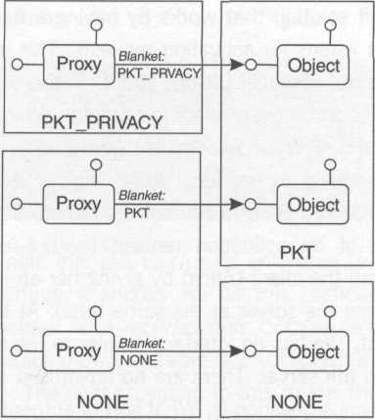
Figure 9.6 Negotiating a default authentication level

A server can't adjust the low-water mark once it's been set. All clients that make calls into the server must come in at least as high as this process-wide setting. A server that wants to receive calls from secure and nonsecure clients (clients who cannot be authenticated) has traditionally been a tremendously difficult problem to solve without dropping the server's process-wide low-water mark to none, which isn't usually a desirable option. COM+ library applications provide an interesting workaround that I'll discuss later in this chapter.
What if your COM client also acts as a server (perhaps because it receives callbacks)? You have a single setting that controls two very different mechanisms. Carefully consider the authentication setting for your applications with this in mind.

Activation Requests
MSRPC doesn't support any sort of activation mechanism; it's assumed that by the time the client begins issuing calls to the server, the server is already running and listening for incoming calls. COM makes no such assumption, and provides several functions (CoCreateInstanceEx being the most popular) that will lazily start a server process if there isn't already one laying around. This is a very simple one-off solution that works by having a daemon on the server machine that always listens for activation requests. This daemon is known as the COM Service Control Manager (SCM), and it runs in the RPC subsystem in the System logon session on every machine running Windows 2000 or earlier versions of Windows NT. When Alice calls CoCreateInstanceEx, the COM library passes this request to her local SCM, which uses an RPC interface known as IRemoteActivation to contact the remote SCM.
The whole idea of an activation request (CoCreateInstanceEx and friends) is to bootstrap the client (Alice) by giving her an interface pointer to a server (often launching the server at the same time). At the time Alice issues the activation request, she has no interface pointer to the server; thus, she has no binding handle to the server. There are no advertised default settings from the server. So the obvious question is, what sort of authentication settings does COM use for activation requests? There are two answers to this question.
First of all, Alice can control these settings explicitly by specifying a coauthinfo data structure:

typedef struct _C0AUTHINF0
{
DWORD dwAuthnSvc;
DWORD dwAuthzSvc;
LPWSTR pwszServerPrincName; // use SPN for Kerberous
DWORD dwAuthnLevel;
DWORD dwImpersonationLevel; // at least IMPERSONATE
COAUTHIDENTITY RPC_FAR *pAuthIdentityData;
DWORD dwCapabilities;
} COAUTHINFO;

These settings should look awfully familiar: they are the same parameters Alice would normally pass when calling SetBlanket. After she fills out this structure, she passes it to CoCreateInstanceEx by attaching it to a coserverinfo structure:

typedef struct _COSERVERINFO
{
DWORD dwReserved1;
LPWSTR pwszName;
COAUTHINFO* pAuthlnfo; // hang it here!
DWORD dwReserved2;
} COSERVERINFO;

It's important to note that pAuthInfo is only used to indicate to the SCM the authentication settings it should use for this particular call to IRemoteActivation. The pointer Alice receives from CoCreateInstanceEx will be set up using the defaults shown in Table 9.2 (coauthinfo generally doesn't affect these defaults). The only exception to this rule is the authentication service negotiation. Here's an example:

ICalc* _createCalculator()
{
COAUTHINFO cai = {
RPC_C_AUTHN_GSS_KERBEROS,
RPC_C_AUTHZ_NONE,
L"HOST/bobsmachine.foo.com",
RPC_C_AUTHN_LEVEL_PKT_INTEGRITY,
RPC_C_IMP_LEVEL_IMPERSONATE, 0, 0};

COSERVERINFO csi = {0, l"bobsmachine.foo.com", &cai};

MULTI_QI mqi = {&IID_ICalc};

HRESULT hr = CoCreateinstanceEx(CLSID_Calc, 0,
CLSCTX_REMOTE_SERVER, &csi, 1, &mqi);

if (FAILED(hr)) _err(L"CoCreateInstanceEx(CLSID_Calc)", hr);
return (ICalc*)mqi.pltf;
}

This code explicitly requests that Kerberos be used for the activation request. The resulting interface pointer will use Kerberos by default as well. Note also that the code uses an impersonation level of impersonate. It's critical that Alice give the local SCM a strong enough token (in other words, a strong enough impersonation level) to allow access to her network credentials. If Alice had instead specified identify_level impersonation, the activation request would have failed.
Now what if Alice had instead passed NULL for pAuthInfo (like most folks do)? The answer is that Alice's SCM will do its very best to establish an authenticated connection to the remote SCM, but if all tries at authentication fail (over all possible network protocols supported by COM on Alice's machine), it will back off and try again without authentication. Is this good? Well, it works quite well assuming that authentication succeeds. But (to take an example) if the client and server are in different domains, and there isn't a trust path from the server's authority to the client's authority, you have two choices: either wait five minutes or so for CoCreateInstance(Ex) to succeed (only after failing authentication will it retry again without authentication), or be explicit and pass a coauthinfo structure saying that you don't want authentication at all (you specify this by setting the authentication service and level to NONE):

HRESULT _activateUnauthenticated(REFCLSID clsid, wchar_t* pszHost,
CLSCTX clsctx, DWORD cmqi, MULTI_QI* rgmqi)
{
COAUTHINFO cai = {RPC_C_AUTHN_NONE, RPC_C_AUTHZ_NONE, 0,
RPC_C_AUTHN_LEVEL_NONE,
RPC_C_IMP_LEVEL_IMPERSONATE}; // meaningless now

COSERVERINFO csi = {0, pszHost, &cai};

return CoCreatelnstanceEx(clsid, 0, clsctx, &csi, cmqi, rgmqi);
}

This handy helper function can be used in systems where authentication is not desired. (Hey, some folks just want to turn off security, and to do this, you have to turn off authentication.)
FAQ: Can I Use Kerberos without Calling SetBlanket?
Think about this problem for a moment. Both RPC and COM guarantee mutual authentication when using the built-in Kerberos SSP. To guarantee mutual authentication, the client's SSP must verify (via Kerberos) the server's identity. This means obtaining a ticket for that server principal (Bob, say), handing it to him, and asking him to prove that he knows the session key buried inside the ticket. Because the ticket is encrypted with a key that only Bob should know, this shouldn't be a problem if Bob really is the principal that the client (Alice) thinks he is.
Here's the problem. How does Alice figure out the server principal in the first place? If Alice simply relies on the default negotiation algorithm and doesn't call SetBlanket to specify a server principal name, what will the server be proving? He'll be proving that he is who he advertised he was during OXID resolution. This isn't terribly interesting and doesn't help Alice much, unless she's content to make a call to the server, verify that Kerberos was used, and then read the server principal name by calling CoQueryProxyBlanket. What would a program do with this information? How could it validate it?
This is a really difficult problem to fix. The directory service in Windows 2000 provides some infrastructure for automating the authenticated discovery of principal names for services, but unfortunately, as of this writing COM doesn't participate in this scheme. In talking with a buddy of mine on the COM team at Microsoft, I found out that COM still does make an attempt to select Kerberos by default. The way it works is this: during an activation call (CoCreateInstanceEx and friends), the client's SCM sets up an authenticated connection with the server's SCM using SPNEGO (assuming the caller didn't use an explicit coauthinfo structure specifying otherwise). If Kerberos is negotiated during that activation request, then the client now at least knows that the server does in fact support Kerberos. Because the SCM runs in the System logon session, it runs with the machine's credentials; thus, COM can make an educated guess at the server principal name by looking at the host name used by the client in the activation request. Assuming the machine name was specified as bobsmachine.foo.com, COM uses "RPCSS/bobsmachine.foo.com" as the server principal name, which Kerberos translates to "HOST/bobsmachine.foo.com", which should work assuming that this name is registered for the server in the directory service (which will normally be the case for any machine that is a member of a Windows 2000 Kerberos domain; see the MSDN documentation for DsWriteAccountSpn for more details). Because COM caches SCM-to-SCM connections on a per-client logon session basis, your application may not be the one that ends up making this negotiation happen; the negotiation may have already occurred using a non-Kerberos friendly host name. If the activation request successfully authenticates using Kerberos as the negotiated protocol, COM remembers this, and the resulting proxy will also use Kerberos by default.
The moral of the story is this: unless you're careful, you won't end up using Kerberos by default for DCOM authentication (you'll often end up negotiating down to NTLM). Want a solution? During activation requests, use a coauthinfo that demands Kerberos. If you get an interface pointer via some other mechanism, demand Kerberos by calling SetBlanket. In both these cases, you'll need to specify a valid principal name for the target. Of course this won't work if the server doesn't actually support Kerberos, but generally speaking, you'll know this (perhaps via configuration information) ahead of time. One hopes that in the future COM will integrate with the directory service a bit better in order to mitigate this headache.
If you are using Kerberos in an attempt to delegate the client's credentials, be aware that in order to send the server a forwarded TGT, the server principal (or the server's machine account if the server runs in the System logon session) must be marked "Trusted for delegation" in the directory. Also, the client's account must not be marked "Account is sensitive and may not be delegated." If this is true, and the client specifies an impersonation level of rpc_c_imp_level_delegate, the client-side SSP will send a forwarded TGT to the server, thus delegating the client's network credentials (see Chapter 7 for more details on Kerberos and delegation of credentials).

More COM Interception: Access Control
If a server (Bob) sets his low-water mark to something other than none, he is stating that every single external client that makes calls into him is required to establish a logon session of one form or another on his machine so that he has the chance to get a token and examine the client's security attributes. Although Bob can do this manually in each of his method implementations, the COM channel is perfectly happy to perform an automatic process-wide access check on Bob's behalf. This is what the first parameter to CoInitializeSecurity (pSecDesc) is all about.
COM caches this security descriptor, and the channel calls AccessCheck at each incoming client request, using the client's token, the cached security descriptor, and an access mask of com_rights_execute (defined in OBJBASE.H):

#define COM_RIGHTS_EXECUTE 1

If access is granted, the call will be dispatched to the object. If not, the call will not be dispatched, and the client will receive the error code e_accessdenied. The generic mapping used for the call to AccessCheck is empty (whoops), so be absolutely sure to grant or deny the specific right com_rights_execute and avoid using generic permissions in the DACL. If you want to turn off this access check completely, pass NULL for pSecDesc in your call to ColnitializeSecurity.
Because COM uses the security descriptor exactly as you provide it, you must provide a fully formed descriptor (this is annoying, but true). This means you must populate the descriptor with an owner and group SID; otherwise, an internal test run of AccessCheck will fail miserably and CoInitializeSecurity will complain. You could go ahead and call CreatePrivateObjectSecurity yourself to populate these settings automatically from the defaults in your token, but another bizarre requirement of CoInitializeSecurity is that the descriptor must be in absolute form (CreatePrivateObjectSecurity returns a self-relative security descriptor). This is also annoying, but once you understand the fragilities of CoInitializeSecurity, it's quite easy to work around them and amaze your friends.
One thing you should watch out for is to always grant access permissions to the System logon session. If you forget to do this, bad things will happen when a client attempts to activate your server. During OXID resolution your local OXID resolver (OR) will attempt to reach into your COM server to ask it to load an RPC transport and start listening. Because the OR runs in the System logon session, it will be denied if you've forgotten this magical step, and the poor devil who's activating your server will get an error code that ranges from e_outofmemory to e_accessdenied, depending on the weather.
You can pass two other forms of information via pSecDesc (besides a security descriptor) that indicate a COM server's access control policy. The first option is to pass an AppID, which is the mechanism typically used by surrogate processes (as is discussed shortly). The second form that you can pass is an implementation of IAccessControl, a COM interface that represents a discretionary access control policy that can be used on platforms where the security descriptor APIs are not present (Windows 9x, UNIX, etc.). The data structures used by this interface are deprecated. (They enjoyed brief popularity during the early betas for Windows NT 5, but the functions that used them were obsolete by the time Windows 2000 beta 2 shipped.) In short, avoid this interface unless you're forced to use it because your COM server runs on Windows 9x or UNIX (in which case you probably have bigger problems anyway). If you pass an IAccessControl pointer, be sure to indicate this by passing eoac_access_control via the dwCapabilities parameter.

Plugging Obscure Security Holes
CoInitializeSecurity allows you to pass a set of capability flags. How the cloaking flags work has already been described, along with the fact that COM ignores the mutual authentication flag. What this chapter has not yet talked about is two of the more esoteric flags, eoac_disable_aaa and eoac_secure_refs
The first of these flags (introduced in Windows 2000) plugs a minor security hole during activation. Because the client (Alice) is required to use an impersonation level of at least impersonate during an activation request, if the target COM server is designated to run As Activator (in dcomcnfg.exe, this is the "Launching user" option), it will run in the network logon session established by the SCM when authenticating Alice. Anything that server does (at least locally) will be done on Alice's behalf, and if it does evil things, Alice probably won't be happy.
Prior to Windows 2000, there wasn't any way for Alice to protect herself from As Activator servers other than not to make COM calls to them at all. But because Alice can't necessarily tell how a remote COM server is configured at any given time, this meant she couldn't safely make any COM activation requests to servers whose configuration she doesn't control. By specifying eoac_disable_aaa via CoInitializeSecurity in Windows 2000, however, Alice can tell her local SCM to communicate to the target SCM that she isn't willing to allow any COM servers to run in her logon session.
Another really twisted attack can be executed by anyone who is knowledgeable about how IRemUnknown works. If Alice makes a COM call to Fred (a bad guy), and she gives Fred a copy of an interface pointer that she holds, Fred can marshal that interface pointer to get its context-neutral representation, tweak the count of public references in that representation, and then call CoReleaseMarshalData, forcing a call to IRemUnknown::Release that can release all public references to the remote stub. This causes the stub to shut down, and leaves Alice holding a dangling reference (her next call through the proxy will fail).
The obvious solution to this problem is for Alice not to give away her pointer in the first place. (There's a growing camp of COM developers who believe that clients should never share their references with other clients.) If Alice doesn't buy into this first solution but wants to be protected from this attack, she should specify EOAC_SECURE_REFS in her call to CoInitializeSecurity. This causes an extra round-trip to the server each time she unmarshals an interface pointer; the extra round-trip is a call to IRemUnknown::RemAddRef requesting a private reference specifically for Alice. The stub manager will keep track of this reference separately, so that if Alice gives her pointer to Fred, and Fred drops the stub's public reference count to zero, the stub will stick around because it still has an outstanding private reference for Alice (which cannot be released by Fred, only by Alice). If Alice doesn't like this extra round-trip, maybe she should reconsider sharing pointers with Fred.

Security in In-Process Servers?
One of the limitations of CoInitializeSecurity is that it can only be called once per process. This is a reasonable limitation given the race conditions that would arise if it could be called multiple times, but what the heck do you do if you're writing a DLL?
By the time a DLL is loaded, the process-wide security settings have already been configured, either because the client called CoInitializeSecurity explicitly or because COM went ahead and made best guesses on the client's behalf. That's right – if you forget to call CoInitializeSecurity, COM will configure your settings automatically (I'll talk more about this later).
From a security standpoint, DLLs are just guests in the host process. This means that they run in the same logon session as the client (the DLL has the same security context as its host process). So there's not much to say here, other than you can't really control the security environment of an in-process server independently from that of its host.

Surrogates and Declarative Security
As of Windows NT 4 Service Pack 2, a feature known as DLL surrogates was introduced, which allows arbitrary COM servers packaged in DLLs to be hosted out-of-process (to allow them to be sandboxed, remoted, etc.).
The way this works is a thing of beauty. The developer simply creates a unique GUID that represents a logical application, and registers this under hkey_classes_root\appid in the registry of the machine where the DLL will be hosted. She then adds a named value DllSurrogate under this key (containing an empty string by default, or the name of a custom surrogate EXE):

HKCR\AppID\{DEADBEEF-0000-0000-0000-ABBADABBADOO}
DllSurrogate=""

Now the developer chooses COM classes from any DLL installed on the machine, and directs them to run in her logical application by adding a named value AppID linking the class back to the application:

HKCR\CLSID\{12341234-1234-1234-1234-123412341234}
AppID="{DEADBEEF-0000-0000-0000-ABBADABBADOO}"

She can do this for as many classes in as many different DLLs as she likes (see Figure 9.7). The result is that COM will treat each logical application as a separate out-of-process server, and the natural allocation of processes will be one process per application. This is simply a declarative way to paste together a process (Figure 9.7 also shows the results). The default surrogate process is known as dllhost.exe.

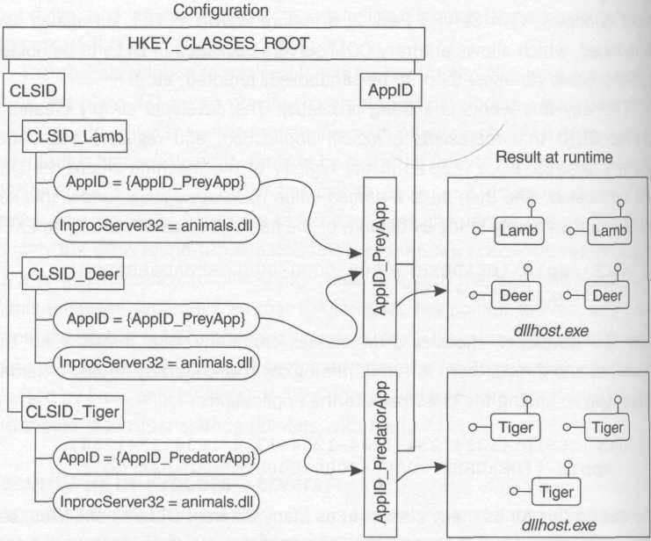
Figure 9.7 Configuring base COM surrogates via ApplDs

Each of these processes will probably want to configure security, but because a DLL cannot call CoInitializeSecurity for the reasons outlined earlier, these settings must be configured declaratively, and it makes complete sense to place these declarations in the registry as part of the definition of the logical application (the AppID).
Besides DllSurrogate, there are a number of other named values you can specify under your AppID key in order to configure the process-wide security settings for the application:

- AuthenticationLevel This maps directly to the dwAuthnLevel parameter in CoInitializeSecurity, and sets the process-wide default authentication level. Remember that this is the low-water mark when the application acts as a server; when the application acts as a client, it contributes (along with the server's advertised authentication level) to negotiating the default authentication level for proxies.
- AccessPermission Controls who is allowed to make calls into the process (this maps directly to the pSecDesc parameter in CoInitializeSecurity). The format is that of a serialized (self-relative) security descriptor.
- LaunchPermission Controls who is allowed to launch processes via activation requests. The format is that of a serialized (self-relative) security descriptor. More on this later.
- RunAs Selects a logon session for the application to run in. More on this later.

The surrogate process (dllhost.exe or your own custom surrogate) will call CoInitializeSecurity in a special way in order to pick up the first two settings (LaunchPermission and RunAs are only used by the SCM at activation time). Instead of passing a security descriptor via the first parameter (pSecDesc), the surrogate will pass a pointer to a GUID. This GUID is none other than the AppID, the identifier for the logical application that the process is hosting. To instruct CoInitializeSecurity to interpret the first parameter as a GUID rather than a security descriptor, the surrogate passes the special flag eoac_appid via dwCapabilities. This tells COM to ignore all the rest of the parameters to CoInitializeSecurity and pick up the process-wide security settings by looking in the registry under the specified AppID, where these settings can be configured declaratively.
At this point I should note that there is also a set of machine-wide security settings that will be used if the respective setting under the AppID key cannot be found. These settings are configured via named values that fall under the

HKLM\Software\Microsoft\OLE key:

- EnableDCOM Set this to 'Y' to enable the local SCM to accept incoming activation requests via IRemoteActivation. Otherwise, all incoming remote activation requests and outgoing remote method calls will fail.
- LegacyAuthenticationLevel This is the machine-wide default authentication level. It's interesting to note that this setting defaults to rpc_c_authn_level_connect. Authentication is required in COM by default, as opposed to its close cousin RPC, where the client must explicitly request authentication. In fact, if you delete this named value from the registry completely, connect will be the implied setting.
- LegacyImpersonationLevel This is the machine-wide default impersonation level. This setting defaults to rpc_c_imp_level_identify. Note that this setting cannot be set on a per-AppID basis; this seems to me to be an oversight.
- LegacyMutualAuthentication Maps to EOAC_MUTUAL_AUTH, which is ignored anyway.
- LegacySecureReferences Maps to the EOAC_SECURE_REFS capability. Note that this cannot be set on a per-AppID basis.
- DefaultAccessPermission This is the machine-wide default access permission. The format is that of a serialized (self-relative) security descriptor.
- DefaultLaunchPermission This is the machine-wide default launch permission. The format is that of a serialized (self-relative) security descriptor.

Note that there are no registry settings for choosing a default authentication service; the only way to configure this is to explicitly call CoInitializeSecurity (without using eoac_appid) and specify all the arguments manually.
The horribly bug-ridden but ever-so-lovable tool used by developers to configure ApplDs is dcomcnfg.exe (Figure 9.8). The figure maps the GUI controls to the corresponding registry settings listed here.

COM Servers Packaged as Services
It's possible to indicate to the COM SCM that you'd like it to call start service as opposed to CreateProcess when a COM activation request requires a COM server to be launched. To do this, you of course need to write a service, install it via CreateService, and link all your classes to an AppID (in the same fashion described earlier for surrogates, although in this case because you're providing the host process, it's your responsibility to expose all the class objects from your service via CoRegisterClassObject).

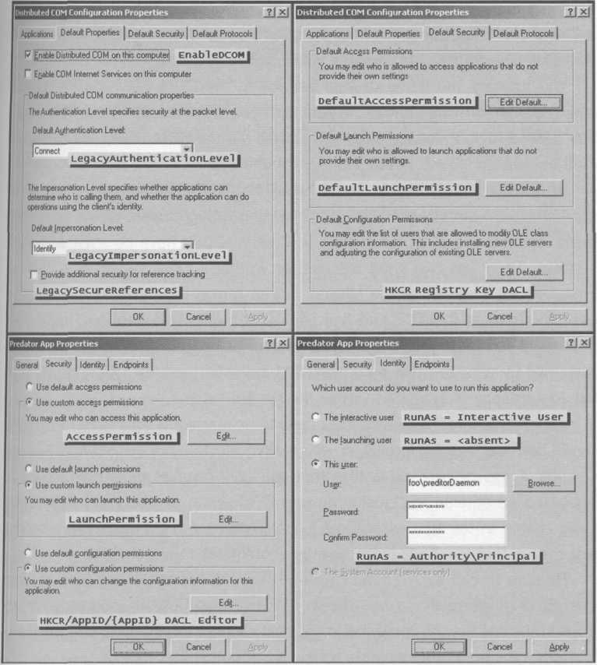
Figure 9.8 dcomcnfg decoder ring
You indicate the name of your service to the COM SCM via the LocalService named value under the ApplD. If you want a specific set of parameters passed to your service when it's started via the COM SCM, you can specify these via the ServiceParameters named value.
Why write a COM server as a service? That's a really good question, since the COM SCM already provides a facility for starting servers on an as-needed basis (services are great for hosting RPC servers that have no such activation service). There are two good reasons for writing a COM server as a service: first, writing a service is the natural way to run in the System logon session (which is part of the TCB and has godlike authority over the local machine). Second, if you want your COM server to start at boot time, before anyone gets a chance to activate it via a normal COM activation request, the System SCM would be happy to bootstrap you as the system loads.
If you're writing five servers that need to be started at boot time (or need to run in the TCB, heaven forbid), do you really need to write five services? I hope Chapter 4 has helped you realize that you only need at most one service to bootstrap the others. Don't just write your COM server as a service because that radio button in the ATL wizard looks cool. Writing a COM server as a service just means that you have twice as much configuration to get right.
Be sure to call CoInitializeSecurity, either specifying your settings directly or by using the eoac_appid trick to cause COM to look up your settings in the registry. As you'll see in the next section, forgetting to call this function often leads to unpredictable behavior.

Legacy Out-of-Process Servers
When a process that uses COM hasn't bothered to call CoInitializeSecurity explicitly, COM will set up the default process-wide security settings automatically using the various registry settings described earlier. If COM can find an ApplD for your server, then at least you can control this application's settings individually. Otherwise, COM will pick up the machine-wide settings, which most legacy COM applications share. If you have an existing out-of-process server for which you need to control security settings, yet you aren't allowed (for whatever reason) to change the source code to call CoInitializeSecurity, you're not entirely out of luck, although the feature I'm about to describe may not give you much hope.
You can create an AppID for your server after the fact, but because you cannot call CoInitializeSecurity to indicate which AppID is yours, you must instead create a subkey under hkcr\appid and name it after your EXE's filename. (Hey, I'm just the messenger here, so don't throw tomatoes at me.) This key should have a single named value under it that links your EXE to its AppID:

HKCR\AppID\legacy.exe
AppID="{DEADBEEF-0 000-0000-0000-ABBADABBADOO}"

The problems with this approach are numerous. The obvious problem is uniqueness, and using a long filename to ensure that your name is unique will likely just complicate things. Relying on this mechanism is also troublesome because as soon as somebody renames the EXE, the mapping is lost and suddenly all the security settings you've been relying on are no longer in effect. I call this the Fragile EXE-to-AppID Mapping Problem, it's so darn prevalent. The ATL wizard (at least as of this writing) doesn't generate a call to CoInitializeSecurity; rather, it writes registry scripts that give you an EXE-to-AppID mapping. This mapping falls down quite badly for people who have two different names for their EXEs, one for debug and one for release builds.
I'll stop ranting now. In summary, don't rely on this mapping, period. Call CoInitializeSecurity, specifying your settings directly or simply telling COM where to find an AppID that holds your declarative settings. Or, don't write an EXE at all – just write a DLL and use a surrogate process (configured components fall under this latter umbrella, as you'll see a bit later).

Launching Servers via the COM SCM
When the COM SCM goes to launch a server in response to an activation request, it asks itself two questions:

- Is the caller allowed to launch this COM server?
- Which logon session should I run this COM server in?

To answer these questions, the COM SCM cannot rely on the server process calling CoInitializeSecurity (or any other function) because, well, the server isn't even running yet. So the COM SCM looks for a security descriptor and a RunAs setting in either the COM+ catalog (for configured components) or in the registry.
In the case of a base COM component, the SCM looks up the CLSID being activated under hkcr\clsid, and discovers the AppID named value. Then it traverses over to hkcr\appid and looks up the LaunchPermission named value. If this information cannot be found (either because there is no CLSID-to-AppID mapping, or because there is no LaunchPermission named value), the SCM looks at the machine-wide DefaultLaunchPermission setting to get this information. If this key is not found, all launch requests will be denied.
Once this security descriptor is found, the SCM performs an access check using this security descriptor, the token from the client's logon session (established during the IRemoteActivation request), and an access mask of (once again) com_rights_execute. If access is denied, the activation request fails and the activator receives the failure code e_accessdenied.
If the client's activation request reached the server at an authentication level of none, there will be no client logon session from which to get a token in order to call AccessCheck. In this special case, the SCM grants the request based on whether the Everyone SID has been granted com_rights_execute permissions. The moral of the story here is that if you want unauthenticated users to be able to launch your COM server, you must grant LaunchPermission to the Everyone SID.
Assuming the activation request gets past the launch permission access check, the SCM must now determine the security context in which to host the server process. (All processes must run inside a logon session; the question is, which one?) If you choose to host COM objects in a service, it's not the COM SCM that needs to worry about this; rather, it's the System SCM, so you can configure this when you call CreateService (see Chapter 4). Otherwise, the COM SCM will need to pick an appropriate logon session, and to do this, it will follow the CLSID-to-AppID mapping and look under the AppID for the value named RunAs. There are three possibilities:

- RunAs=<absent> (As Activator activation) Run As Activator occurs when there is no RunAs named value at all (thus this is the default setting for base COM servers). The COM server will always run in the logon session of the activator, established during the call to IRemoteActivation. This means that there must be a logon session for the client; thus, activation will fail if the client request comes in at an authentication level of none. This also means that each client principal will get his or her own personal copy of the server process.
- RunAs="Interactive User" In this case, the SCM will look for the existence of an interactive user (specifically, someone who logged on via Winlogon). If there is one, the COM SCM will discover the interactive user's token using an undocumented mechanism and start the server process running with a copy of that token, at the same time directing the server onto the interactive window station. If no interactive user is present, all activation requests will fail. If an interactive user happens to be present and your server starts in her logon session and then she logs off, your server gets toasted along with the other processes running in her logon session.
- RunAs="Authority\principal" In this case, the SCM attempts to establish a batch-style logon session using the authority and principal specified here, and the password stored in the password stash at index scm = appid, where appid is the stringized GUID for the application. The SCM then launches the server in this logon session.

Figure 9.9 shows how these settings affect the logon session (and window station) in which the application will be hosted. Internalizing this picture will help you develop a more intuitive feel for how COM servers work.
With these facts out on the table, here are some interesting corollaries. First of all, the default setting of Run As Activator makes lots of sense for the thousands of applications that use COM for binding user interfaces together using OLE. These applications weren't designed to be activated by remote users, and thus would be prime candidates for exploitation by a bad guy. Because the default is Run As Activator, if some bad guy (Fred, say) does attempt to launch Microsoft Word on AlicesMachine via DCOM, it won't work unless the system can establish a logon session for the bad guy on AlicesMachine. Even if Fred is clever and figures out how to get COM to use a NULL session or a Guest logon, it's unlikely that these security contexts will make it past the DACL in DefaultAccessPermission for the machine. Even if Fred makes it past all of these hurdles, the server application will run in a logon session that was established with his authorization attributes, which will severely limit what he can do. (Look, if the bad guy is the domain administrator, you have worse problems than COM security to worry about.) Also, because this is a daemon logon session, the application will run in a noninteractive window station and won't be able to do nasty things like put up dialog boxes requesting passwords, or send keystrokes to the shell to do evil deeds.

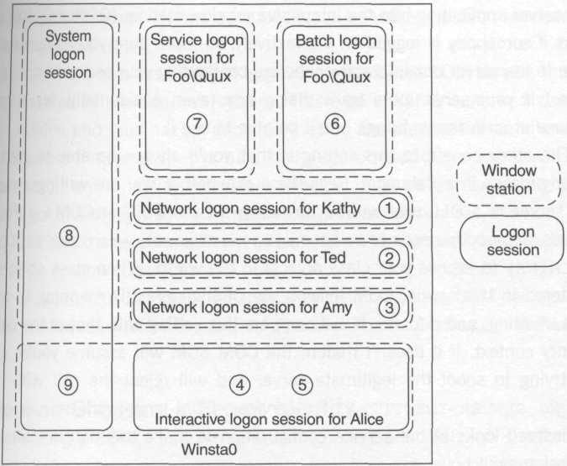
AlicesMachine
(1) RunAs=<absent>, activated remotely by Kathy
(2) RunAs=<absent>, activated remotely by Ted
(3) RunAs=<absent>, activated remotely by Amy
(4) RunAs=<absent>, activated locally by Alice, the interactive user
(5) RunAs="Interactive User"
(6) RunAs="Foo\Quux"
(7) Service configured to run as "Foo\Quux"
(8) Service configured to run as system, noninteractive
(9) Service configured to run as system, interactive
Figure 9.9 RunAs decoder ring

All this being said, Run As Activator is truly miserable if you have designed your server specifically to service remote activation requests from multiple client principals. Unless you enjoy having multiple copies of your server being launched (one per client principal, which can get really expensive and kills any chance of pooling database connections), don't leave the RunAs setting absent for a base COM server of this type.
Run As Interactive User is great for debugging in the lab, because it forces your server application into the interactive window station. (Of course, this only works if somebody is logged on interactively, so make sure you have someone log in to the server box interactively before configuring your server to run in this mode.) If your server puts up a dialog box (even accidentally, for instance because of an assert firing), you'll be able to see it.
The other benefit to this setting is that you'll always be able to start the server process in a debugger. Regardless of whether you are writing a classic EXE server or a DLL that will be hosted in a base COM or COM+ surrogate process, somebody needs to call CoRegisterClassObject (clsctx_local_machine) to expose your class objects to the world. When class objects are registered in this scope, COM follows the CLSID-to-AppID mapping to find a RunAs setting, and if found, it will compare this setting with that of the caller's security context. If it doesn't match, the COM SCM will assume you're a bad guy trying to spoof the legitimate server and will reject the call with co_e_wrong_server_identity. For services, COM ignores the RunAs setting and instead looks at the service configuration to make this determination. All this being said, however...
Never, never, never ship code that configures itself to run as the interactive user unless you are absolutely sure that it is safe. No, I take that qualification back. Don't ever do it, period. If your code has any weakness that an attacker can exploit (or if it can be used to do obviously dangerous things like deleting files), and an administrator happens to be logged on interactively to a machine where your program is configured to run as the interactive user, an attacker can exploit that bug in the security context of the administrator. (The administrator's interactive logon session will have network credentials; imagine what damage could be done with a domain administrator's credentials!) This is really bad news. It also brings up all kinds of ethical issues: by activating a COM server in this way, it's as if you've silently reached out and hypnotized the user into launching your application by double-clicking it; even worse, you've told him that he won't remember having done this when he wakes up. No user deserves to be subjected to this.
Run As Distinguished Principal is great for distributed COM servers that are being installed in a production system. This type of server runs in a daemon logon session and thus has no dependencies on the presence of an interactive user. Because the server always runs in the same security context, it will have a more stable environment. The server principal must be granted the right to a batch logon (naturally), so your installation program should set this up. (Typically you'll add the server's account at installation time as well; see the appendix for tips on how to set this up.)
dcomcnfg.exe is a really great tool for switching base COM servers back and forth between Run As Interactive User and Run As Distinguished Principal in the lab.

A Note on Choosing a Server Identity
When running a COM(+) server as a distinguished principal, you should think carefully before choosing a server identity. If your server will not be running on a domain controller, I strongly recommend that you consider using a local account (your setup application can install this automatically; see the appendix for details). By using a local account, you reduce the damage that can be done by an attacker who compromises the server machine and learns the password by looking at the password stash. Local accounts are absolutely the way to go if your server doesn't require access to secure network resources.
However, if your server needs to be authenticated on the network, the decision becomes a bit harder. You can either create a matching user name and password on the target machine(s) where your server needs to be authenticated, or break down and use a domain account that is limited as much as possible (you can restrict the privileges and types of logons it can have throughout the domain using Group Policy, for instance). If you choose to use the matching user name and password kludge, you should consider writing a program to automatically synchronize passwords (the appendix will help with this).

Access Checks in the Middle Tier
In Chapter 3, I promised to provide further explanation for why the impersonation model doesn't work well in a three-tier system. Having the middle tier simply impersonate the remote client and use her credentials to call into the back tier (typically a database) opens a whole host of problems. First of all, as mentioned in Chapter 3, in order for this to work, the client must delegate her credentials to the server. This in itself is reason for concern. Besides the fact that it won't work at all on Windows NT 4 (which uses NTLM), requiring clients to expose their credentials to delegation simply broadens the surface area open to an attacker (by compromising a server machine, the bad guy can now obtain network credentials for clients that delegate them). Limiting the use of delegation is like vaccinating your kids. It tends to limit the spread of sickness throughout a system.
Another major problem is that impersonation in the middle tier completely annihilates any chance of pooling connections to the database. Because each database connection represents an authenticated session (similar to the way LAN Manager sessions work, as described in Chapter 8), these are principal-sensitive resources. If the middle tier wishes to delegate the client's credentials to the database it must open a database connection for each client principal.
Three-tier systems are often built as such not just to separate business logic from database schemas (usually the customer really doesn't give a darn how object oriented your internal implementation is), but rather to offload as many machine instructions as possible from the database and transfer them to a middle-tier server farm where hardware is cheap and can be replicated as needed. By performing access checks in the middle tier and pooling database connections, the middle tier communicates with the database using a single set of credentials that the database can quickly authenticate (at database connection time via a handshake, and thereafter using a session key). The database trusts the middle tier to perform access checks and can therefore focus on doing what it does best: executing SQL queries and stored procedures as blazingly fast as it possibly can. Figure 9.10 shows the two diametrically opposed strategies.

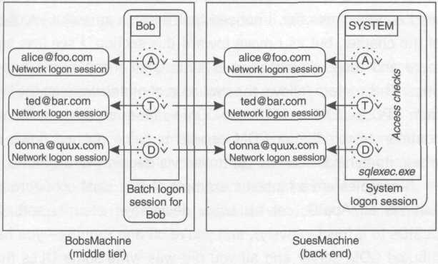
Scenario 1: free for all!
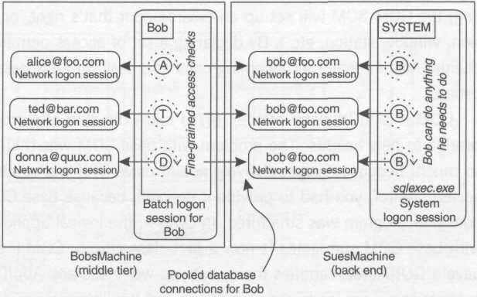
Scenario 2: coordinated access checks between middle and back tiers allow database connection pooling
Figure 9.10 Two strategies for access control

Now that I've explained the need for access checks in the middle tier, let's look at how COM+ helps to automate this.

The COM+ Security Model: Configured Components
As I was writing this chapter, I noticed an interesting pattern. I started the chapter talking about RPC security and then migrated into base COM security, and now I'm going to start exploring the added security features that COM+ configured components offer. I noticed that there is an awful lot of code at the start of the chapter, but as I move toward this section, I see less and less code and more and more explanations of automated mechanisms and declarative settings. This pattern follows the evolution of middleware on the Windows platform from RPC to COM to MTS and COM+. More and more of the boilerplate code common to middle-tier COM servers is being pushed down into the runtime where its behavior can be controlled via declarative attributes.
Surrogates are a fantastic example of this: just configure a logical application via an AppID, set up some declarative security settings, attach some CLSIDs to it (declaratively), and you're off and running – you have a secure distributed COM server and all you did was write some DLLs that don't concern themselves with authentication or access checks. By declaring a RunAs setting, the COM SCM will set up an environment that's right for you (logon session, window station, etc.). By declaring a set of access permissions, the COM channel will intercept all incoming calls and perform an access check on your behalf.
COM+ (and its baby brother, MTS) takes the idea of surrogates and interception to new heights. The problem with base COM was that it could only do so much, because it was relatively nonintrusive. If you wanted finer-grained access control, you had to provide it yourself, because base COM had no idea how your program was structured. In COM+, the logical application introduced with base COM surrogates is now a first-class citizen. COM+ applications still have a GUID that identifies them, but you won't see any AppID in the registry, because there are loads of new settings and this information is tucked away in the COM+ catalog. The COM+ catalog has knowledge of the structure of the configured components and the applications that house them, and can be used to configure fine-grained security settings.
What you'll find with most of the security settings in COM+ is that generally the COM+ catalog is just another way of declaratively specifying many of the settings that have already been covered. It's mostly a matter of figuring out which setting does what (and getting your head around the role-based security infrastructure).
Another thing that you'll find is that COM+ performs access checks at application boundaries as well as process boundaries, which means that library applications often have a bit more autonomy when it comes to security. This is different from Windows NT 4, where security checks for configured (and nonconfigured) components were only performed when a call entered the process (see Figure 9.11). Note that once the boundary has been crossed, no further access checks are performed (this is indicated via dashed lines between components).

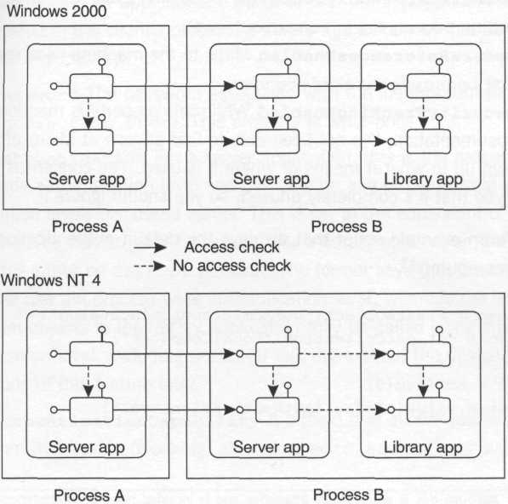
Figure 9.11 Security boundaries

Catalog Settings
The quickest way to get the lowdown on the security-related settings that can be configured in COM+ is to enumerate the properties in the catalog. The first object we'll look at is the LocalComputer object. This object exists mainly as an abstraction over existing machine-wide registry settings; for instance, many of the security settings described earlier as falling under hklm\ Software\Microsoft\OLE can be edited via this catalog object (this directly accesses the registry settings without you having to write registry code).

- DCOMEnabled Maps to the machine-wide registry setting EnableDCOM
- DefaultAuthenticationLevel Maps to the machine-wide registry setting LegacyAuthenticationLevel
- DefaultImpersonationLevel Maps to the machine-wide registry setting LegacyImpersonationLevel
- SecureReferencesEnabled Maps to the machine-wide registry setting LegacySecureReferences
- SecurityTrackingEnabled While this property is mentioned in the documentation, I've not been able to find anyone at Microsoft who will own up to what it means or where it is used. The concensus appears to be that it's completely unused, so you should ignore it.

Here's an example script that displays the default authentication level for the local computer:

set cat = CreateObject("comAdmin.comAdminCatalog")
set cc = cat.getCollection("LocalComputer")
cc.populate
set c = cc.item(O)
msgbox c.value("DefauitAuthenticationLevel")

Now let's look at the security-related properties on each Application object:

- Activation Indicates whether the application is a server or library application. The former activates out-of-process, and the latter activates in-process. Many security settings only make sense for server applications; I'll call these out as I come to them.
- Identity May be either interactive User or the name of a distinguished principal. (Note that Run As Activator is not supported for configured components, and as of this writing, there is no support for running configured components in the System logon session.) If you want to set this value programmatically, make sure you also set the password before committing your changes. This property is only valid for server applications. Because each library application is hosted in the client's process, a library application cannot control its security identity.
- Password The password associated with the identity (unused for interactive user). This property is write-only.
- Authentication For a server application, this is the process-wide authentication level and can take on any of the normal authentication levels discussed earlier. This is set to the equivalent of rpc_c_authn_level_pkt by default. For a library application, this setting may either be default or none. The former says that the channel will use the process-wide authentication level, whereas the latter says that objects in the library application may be called using any authentication level, including none. I'll talk more about the design implications of this feature later.
- AuthenticationCapability A bitfield that allows you to control identity tracking (cloaking) as well as eoac_secure_refs. As of this writing, this property isn't visible via the Component Services snap-in, but can be controlled programmatically via the catalog interface. The default setting is dynamic identity tracking (eoac_dynamic_cloaking). This is a process-wide setting, and although it's also present in library applications, it is ignored in that context as of this writing. The reason dynamic identity tracking was chosen as the default is that threads in IIS Web applications (which are essentially COM+ applications) are always impersonating, and it's architecturally critical to be able to delegate the thread's security context to other COM objects that the Web application creates. More on this in Chapter 10.
- ImpersonationLevel The process-wide default impersonation level for the application. The default setting is the equivalent of rpc_c_imp_level_impersonation, which is somewhat surprising considering base COM's usual conservative approach to security.
- ApplicationAccessChecksEnabied Determines whether the interception layer should automatically perform access checks. By setting this value to False, any caller who satisfies the authentication low-water mark will be able to make calls into the application without the COM channel performing any access checks at all. This is great for temporarily turning off access checks in the lab when debugging, because it affects the entire application. Access checking is turned off by default, apparently with the assumption that you'll set up role-based security and then enable access checks once you've made these decisions.
- AccessChecksLevel Determines the extent of the access checks that should be performed, as well as the level of security context bookkeeping that should be maintained by the channel. This is a very important (server app only) setting that will be discussed in conjunction with COM+ roles. This setting is not present in MTS.

Here's a script that enumerates all the COM+ server applications installed on the local machine, displaying the identity setting for each via a message box:

function getApplicationCollection
set cat = CreateObject("comAdmin.comAdminCatalog")
set ac = cat.getCollection("Applications")
ac.populate
set getApplicationCollection = ac
end function

set ac = getApplicationCollection()
for each a in ac
if 1 = a.value("Activation") then
s = s & a.name & ": " & a.value("Identity") & chr(13)
end if
next
msgbox s

Besides the COM+ roles that I discuss in detail later, there is one remaining security-related attribute in the catalog, specified on a per-class basis:

- ComponentAccessChecksEnabled Determines whether component-level access checks should be performed for calls originating from outside the application targeting this component. This setting is enabled by default. This and the other access check settings are summarized in the section Making Sense of COM+ Access Checks.

Applications and Role-Based Security
Preparation
Unless you explicitly turn on access checks for an application, the only protection you'll have is the authentication low-water mark for your application. All calls that satisfy this authentication requirement will be allowed through. To ask the channel to perform access checks on your behalf, you must turn on the application-level property called ApplicationAccessChecksEnabled. This setting (as well as virtually all the others I'll discuss) can be configured either via script, or interactively via the Component Services snap-in. The benefit of using a script during development is that it ensures a repeatable configuration (misconfiguration bugs are common in COM+ development), and the script can be checked into source control, where changes can be carefully tracked.
The following script enables access checks for an application named “Pet Store App”:

function findObject(coll, name)
for each obj in coll
if name = obj.name then
set findObject = obj
exit function
end if
next
end function

set ac = getApplicationCollection()
set a = findObject(ac, "Pet Store App")
a.value("ApplicationAccessChecksEnabled") = true
ac.saveChanges

If you're planning on using COM+ role-based security in your application, you'll want to instruct the channel to perform these checks based on fine-grained catalog settings. Each application has a property that controls the granularity of access checks: AccessChecksLevel. This (COM+-only) setting can have the following values:

- COMAdminAccessChecksApplicationComponentLevel Indicates that the role-based access checks on each class, interface, and method should be enforced. This is the default level, and is almost always what you want. As you'll see later, this setting also turns on some extra bookkeeping in the channel.
- COMAdminAccessChecksApplicationLevel Indicates that the role assignments to each class, interface, and method should be completely ignored. As long as the caller is in at least one of these roles, he or she may call any method on any interface on any class in the application. This level basically renders roles meaningless and throws you back to the days of base COM, where there was a single DACL that controlled access to all objects in the process.

Here's a script that forces component-level access checks. Note that I've used the WSF (Windows Script File) format so that I can include the type library for the COM+ catalog (I found this GUID by peeking in the comadmin.dll component with oleview.exe). This allows me to use the enumerations in the type library as opposed to hardcoding constants.

<?xml version="1.0" ?>
<job>
<reference guid="{F618C513-DFB8-llDl-A2CF-00805FC79235}"/>
<script language="VBScript">
<![CDATA[
set ac = getApplicationCollection()
set a = findObject(ac, "Pet Store App")
a.value("AccessChecksLevel") = _
COMAdminAccessChecksApplicationComponentLevel
ac.saveChanges
] ]>
</script>
</job>

So at this point, I've shown you how to turn on access checks for the application and set the access checking level to enable meaningful role-based checks, but there's one more setting that needs to be configured before you can be sure that your class will be protected via role-based security. Each class has a property called ComponentAccessChecksEnabled that must be set in order to enable role-based access checks:

set ac = getApplicationCollection()
set a = findObject(ac, "Pet Store App")
set cc = ac.getCollection("Components", a.key)
cc.populate
set c = findObject(cc, "PetStores.PetStore.1")
c.value("ComponentAccessChecksEnabled") = true
cc.saveChanges

After turning on these checks, if you were to try to use any of the components in the application, you'd find yourself completely locked out (e_accessdenied). The application wouldn't even launch. Role-based security is additive (each caller is implicitly denied unless a role specifically grants him or her access), and currently the Pet Store application has no roles defined at all (the next section discusses how to approach this task).
Designing with Roles
When designing a COM+ application, the designer discovers the various categories of users that need to be distinguished with respect to security. During implementation, these categories are made concrete by adding roles to the application. Chapter 3 introduced the notion of logical roles. (You might want to revisit Figure 3.1, which pretty much sums it up.)
The following script adds three roles to a pet store application (the results are shown in Figure 9.12):

set ac = getApplicationCollection()
set a = findObject(ac, "Pet Store App")
set re = ac.getcollection("Roles", a.key)
re.add.value("Name") = "Customers"
re.add.value("Name") = "Workers"
re.add.value("Name") = "Supervisors"
re.saveChanges

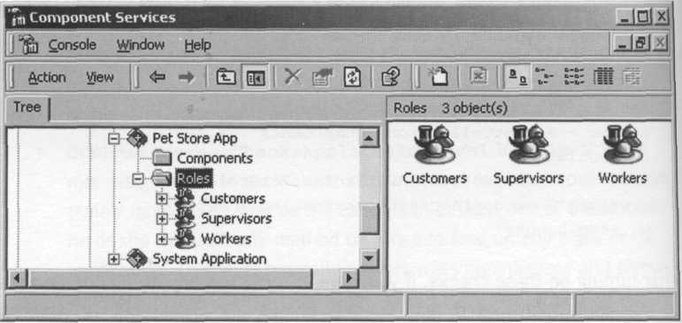
Figure 9.12 Defining roles

After discovering the roles in an application, the designer needs to determine which methods clients in each role should be allowed to invoke. During implementation, these decisions are made concrete by assigning roles to methods (COM+ only), interfaces, and classes. Roles can be assigned either via script or via the Component Services snap-in (you'll find a Security tab on the property sheet for each class, interface, and method). Figure 9.13 shows a sample pet store application with its expanded set of interfaces and methods (there's only one class to keep things simple).

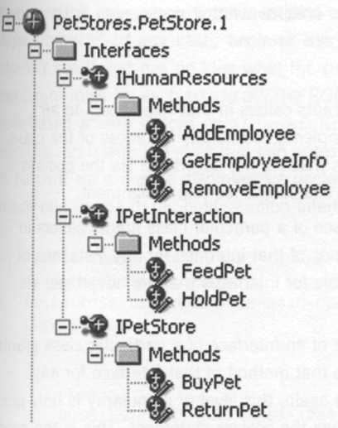
Figure 9.13 Sample pet store application

The only interfaces you'll see in the catalog for a configured class are those that are listed in the coclass statement in the type library; it's completely possible that an object might actually implement several other interfaces as well that aren't advertised via the coclass statement. This doesn't mean that these interfaces escape role-based access checks; what it does mean is that you'll have less granularity of control. Here are the rules:

- A role assigned to a class grants callers in that role access to all methods of all interfaces implemented on any instances of the class. This also includes interfaces that are not advertised via the coclass statement. This is the most coarse-grained role assignment.
- A role assigned to an interface of a particular class grants callers in that role access to all methods of that interface for any instances of the class. This is only possible for interfaces that are advertised via the coclass statement.
- A role assigned to a method of an interface of a particular class grants callers in that role access to that method of that interface for any instances of the class. Once again, this level of granularity is only possible for interfaces exposed via the coclass statement. This is the most fine-grained role assignment (and is not supported by MTS).

Note that if two configured classes implement the same interface, each of those classes has a separate role-assignment space for its interfaces; for example, the role assignments for interface quux on class foo are completely orthogonal to the role assignments for interface quux on class bar.
Dealing with Dispatch Interfaces
Dispatch interfaces can be tricky, depending on how much of a COM purist you are. If you agree with the general consensus in the COM community that dual interfaces are a thing of the devil, then you'll need to do some fancy footwork to get your dispatch interface recognized by COM+. The approach I normally use for supporting scripting clients and vtable-friendly clients is as follows. I provide a hidden interface (one that I don't expose via QueryInterface) that represents the union of all the methods on my normal custom interfaces that I want scripting clients to be able to see. I then implement IDispatch by delegating to the ITypeInfo implementation of this interface that I slurp out of my type library. In any case, because this is a hidden interface, the catalog doesn't see it and has no idea what the dispids are in order to allow you to configure roles for each dispid. (The COM+ interceptor is happy to perform role-based access checks on IDispatch::Invoke as long as you configure each dispid with the roles that can access it.) My solution to this conundrum is to cruft up a classic dispinterface declaration in my type library block that maps one-to-one to my hidden union interface:

// interface IFoo, IBar, IQuux, and IBaz
// omitted for brevity
[uuid(4056311C-E848-473B-B43C-CB4B2 9D2864B)] library Foo
{
[
object,
uuid(A51F6D55-AD0E-4EE3-A2 84-A0805B996BAF),
pointer_default(unique)
]
interface IHiddenUnion : IUnknown
{
[id(1)] HRESULT Foo();
[id(2)] HRESULT Bar();
[id(3)] HRESULT Quux();
[id(4)] HRESULT Baz();
}

[uuid(A5148D55-AD0E-4EE3-A2 84-A0805B996BAF) ]
dispinterface UseThisToConfigureMethodsForScripts
{
properties:
methods:
[id(l)] void Foo();
[id(2)] void Bar();
[id(3)] void Quux();
[id(4)] void Baz();
}

[uuid(0863E813-6C99-42 96-983F-7A5C0 6588E4B), ]
coclass MyConfiguredClass
{
interface IFoo;
interface IBar;
interface IQuux;
interface IBaz;
dispinterface UseThisToConfigureMethodsForScripts ;
};
}

Note that I was careful to explicitly define dispids for my hidden union interface and that I matched these dispids in the dispinterface, method for method. Also note that I exposed this single dispinterface from my coclass statement, which causes the COM+ catalog to provide slots for configuring role-based security on each method (each method is identified by its dispid in a dispinterface).
The following script assigns the Supervisors role to the PetStore class (thus granting access to all methods of all interfaces of the class). Next it assigns Workers to the IPetInteraction interface so that they can hold and feed the pets. Finally, it assigns Customers to the HoldPet method and the IPetStore interface (so they can hold, buy, and return pets, but not feed them).

sub addRoleToClass(cc, className, roleName)
set c = findObject(cc, className)
set re = cc.getCollection("RolesForComponent", c.key)
re.add.value("Name") = roleName
re.saveChanges
end sub

sub addRoleToInterface(cc, className, itfName, roleName)
set c = findObject(cc, className)
set ic = cc.getCollection("InterfacesForComponent", c.key)
ic.populate
set i = findObject(ic, itfName)
set re = ic.getCollection("RolesForlnterface", i.key)
rc.add.value("Name") = roleName
rс.saveChanges
end sub

sub addRoleToMethod(cc, className, itfName, methName, roleName)
set c = findObject(cc, className)
set ic = cc.getCollection("InterfacesForComponent", c.key)
ic.populate
set i = findObject(ic, itfName)
set me = ic.getCollection("MethodsForlnterface", i.key)
me.populate
set m = findObject(me, methName)
set re = me.getCollection("RolesForMethod", m.key)
re.add.value("Name") = roleName
re.saveChanges
end sub

set ac = getApplicationCollection()
set a = findObject(ac, "Pet Store App")
set cc = ac.getCollection("Components", a.key)
cc.populate
className = "PetStores.PetStore.1"
addRoleToClass cc, className, "Supervisors"
addRoleToInterface cc, className, "IPetStore", "Customers"
addRoleToMethod cc, className, "IPetInteraction", "HoldPet", "Customers"

The pet store application is now complete (at least security-wise) as far as the designer is concerned, and he or she can ship it by exporting the application. However, until an administrator installs the application and assigns concrete SIDs to the roles, everyone will be denied access.
Deploying with Roles
Defining roles and assigning them to classes, interfaces, and methods is the job of the application designer, who knows the semantics of the application. At deployment time, the administrator installing the application can assign users and groups to these roles via the Component Services snap-in. Once the administrator has made these concrete assignments, if he needs to replicate the application on several machines in a server farm, he can export the application again, this time specifying the option to "Export user identities with roles." Note that this won't work very well if he's assigned aliases (local groups) to any roles (other than those that are part of the BUILTIN domain, including Administrators, Guests, etc.), because the SIDs for custom aliases only make sense on the local machine. This also applies to local user accounts.
If the administrator wants to copy all the COM+ applications on a server to another server in the farm, he can use the utility comrepl.exe (located in the %SYSTEMROOT%\com directory). This tool exports all applications from a source machine and imports them on the destination machine, effectively copying not only the catalog information but also the components themselves.

Making Sense of COM+ Access Checks
If you look in the Component Services snap-in and consider the various checkboxes and radio buttons that control access checks, and then also consider that the process hosting a server application might host a number of library applications as well, it can be very confusing to figure out exactly how a particular configuration will affect any given call.
I find that the easiest way to understand these settings is to think of several ordered hurdles that you must cross before you can successfully make a call into a configured component. Remember, the target component lives in a single COM+ application (which could be a server or a library application), and the application lives in a single process. Each COM+ server process will host exactly one server application (which controls many process-wide settings, such as the security identity and default impersonation level) and zero or more library applications (a library application has much less control over its security environment than a server application, naturally). Figure 9.14 shows an example.

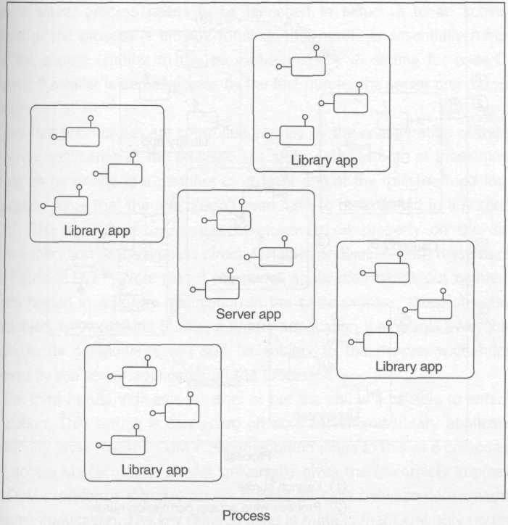
Figure 9.14 A typical COM+ process

Three access control hurdles stand in the way of making a successful call. If you don't get past one of them, you're immediately denied access and cannot move on to the others. These hurdles occur in the following order and at the following points (see Figure 9.15, where it is assumed that causality A caused the process to launch, after which casuality B and C entered the already running process):

- As an activation request causes the COM SCM to consider launching a server process
- As a call enters a process
- As a call enters an application

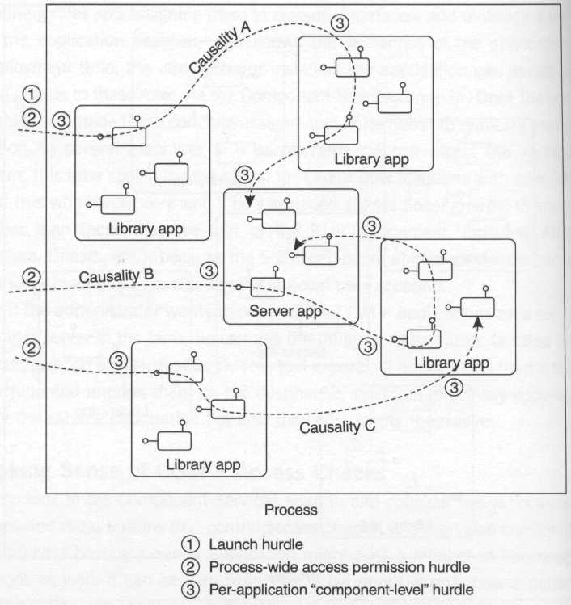
Figure 9.15 The three hurdles

The first hurdle is special because it's evaluated by the COM SCM only when a server process needs to be launched in response to an activation request. If the process is already running, this hurdle is essentially removed from the picture (similar to the LaunchPermission setting for base COM servers). If a caller is denied access by the first hurdle, the server process won't be launched at all.
The first two hurdles are controlled entirely by the configuration of the single server application in the process. The caller satisfies both of these hurdles as long as he or she is a member of at least one of the roles defined for the application (note that the role doesn't even have to be assigned to any components). The ApplicationAccessChecksEnabled property on the single server application in the process directly enables or disables both these hurdles (see Figure 9.16). Note that if the server application hands out pointers to objects hosted in a library application in the same process, those objects are also subject to the second hurdle; a library application that grants everyone all access to its components will still be subject to the process-wide hurdles imposed by the server application in the process.

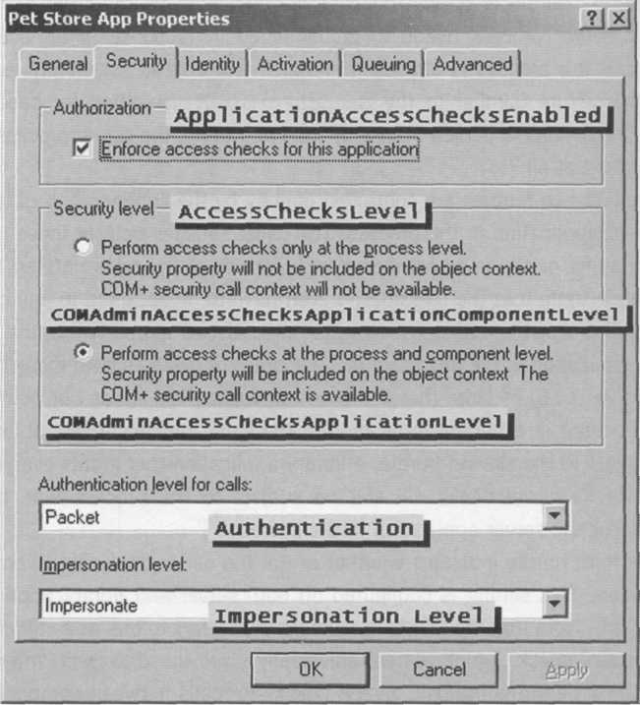
Figure 9.16 COM+ catalog security properties

The third hurdle indicates whether or not the call will be able to enter the application. This setting is configured on both server and library applications individually. Note that the COM+ documentation refers to this as a component-level access check, which almost universally gives the (incorrect) impression that COM+ performs intrinsic access checks for calls between components in the same application. The key thing to keep in mind is that COM only performs this check when a call crosses into the application. Once inside the application, the COM+ channel performs no further access checks.
The reason for the "component-level" label is that the application-entry access check that the channel performs is sensitive to the component targeted by the call (technically, it's sensitive to the targeted method on that component). As long as the caller is a member of at least one role assigned to the target method (or its host interface or class), he or she will satisfy this final hurdle.
Three settings need to be aligned in order for this third hurdle to be erected in front of a particular call. The first and second settings must be configured on the application that hosts the component targeted by the call. The second setting is necessary in order to install interceptors into the channel that perform the fine-grained bookkeeping necessary to implement this level of access control (I'll talk more about this setting a bit later). The third setting must be enabled on the component targeted by the call:

- ApplicationAccessChecksEnabled = True
- AccessChecksLevel = COMAdminAccessChecksApplicationComponentLevel
- ComponentAccessChecksEnabled = True

Figure 9.17 provides a summary of the various options for enabling or disabling these hurdles.

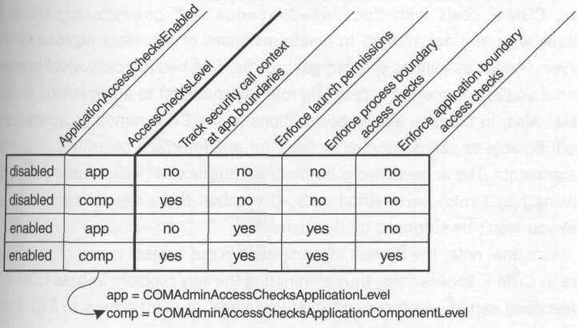
Figure 9.17 Access control decoder ring

As mentioned in footnotes 49 and 50 regarding the second and third hurdles, COM+ deals With CoCreateInstance and QueryInterface in a unique way. You are allowed to create instances of any class exposed by the server process as long as you can get past the first two (process-wide) hurdles, even if you're not granted access (via role assignments) to any methods on that class. Also, in order to allow optimizations in the COM remoting architecture, you'll be able to call QueryInterface for any interface regardless of its role assignments. The access checks for the third hurdle don't kick in until you begin making non-IUnknown method calls. (I mention these special cases only so that you won't be surprised by this behavior.)
As a final note, the System logon session is not subject to any of these hurdles in COM+ applications, thus eliminating the silly problem in base COM that I described earlier which occurs when you forget to grant access to SYSTEM.

Which Components Need Role Assignments?
Most of the COM+ services provided via interception are predicated on the notion that as a client of a configured component you will not share any references to that object with anyone else. Let's say that there exist two configured components, A and B. If a client creates component A, and A creates B, A should generally avoid returning a reference to B back to the client. Ewald (2000) discusses the problems this can lead to if A and B share a synchronization or transaction domain, but sharing object references can make your life more difficult from a security perspective as well.
Designating a small set of classes as the entry point into an application tremendously simplifies the security model. It is these "gateway" classes that need to be assigned roles; the other internal helper classes should have role-based checks enabled (via the ComponentAccessChecksEnabled property), but should have no roles assigned to them whatsoever. This guarantees that external clients will not be able to make method calls directly to these objects, and reduces the surface area that you expose to external clients (which means less potential security holes to plug). As for library applications, in general, I prefer to simply be honest and open them wide by setting ApplicationAccessChecksEnabled to False. Figure 9.18 shows the basic strategy.

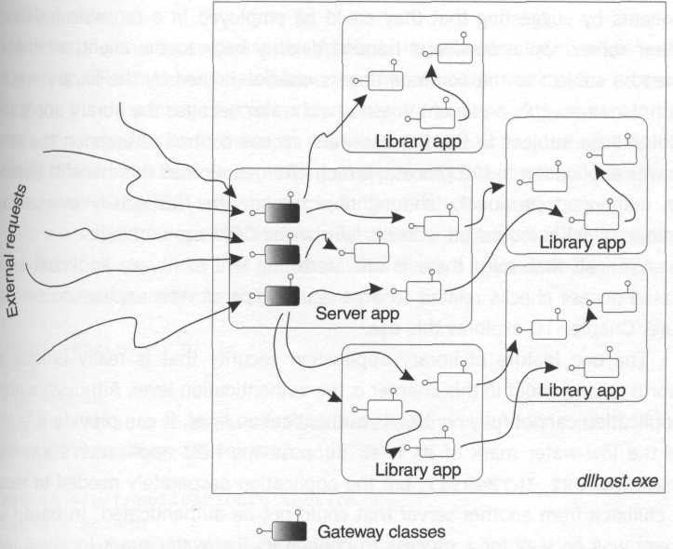
Figure 9.18 Gateway into a COM+ application

Security in COM+ Library Applications
COM+ library applications (unlike MTS library packages) have some distinct security settings. One can define roles in a library application and assign them to classes, interfaces, and methods, just as with a server application. Although academically interesting, the security of this mechanism is questionable at best, because any in-process component is subject to the whims of its client, who (if clever) can simply reach past the interceptor and call directly into the object.
One might rationalize the need for role-based access checks in library components by suggesting that they could be employed in a reusable fashion by other server applications and handed directly back to the client, who would then be subject to the common access checks defined by the library application. However, this argument doesn't hold water because the library application will still be subject to the process-wide access control settings on the single server application in the process, which often eliminates this benefit. Besides, I as mentioned previously, sharing object references (especially transactional components) is looked on with disdain by the COM+ plumbing.
With all that said, there is an interesting use of library application role-based access checks related to a particular type of Web application architecture; Chapter 10 explores this use.
The one feature of library application security that is really unique and worth talking about in this chapter is the authentication level. Although a library application cannot fully control its authentication level, it can provide a "notch" in the low-water mark of its host. Suppose the host application's low-water mark was pkt_integrity, but the application desperately needed to receive a callback from another server that could not be authenticated. In base COM, there was no way for a process to change its low-water mark to allow unauthenticated callbacks (all COM channels in a process respected the single process-wide authentication level). In COM+, however, each library application has the choice of retaining the authentication level set by the server application in the process, or choosing the equivalent of rpc_c_authn_level_none, thus creating the notch mentioned earlier. By giving out a reference to a component in a library application configured in this fashion, it's now possible to receive unauthenticated callbacks to that object, despite the process-wide low-water mark. (Yes, this is sharing an object reference, but in this case, you'll likely only be using this object to tunnel into the application via an unauthenticated call; the object will almost invariably be nontransactional.)
Although most security experts will probably shun this feature, I've talked to many developers whose projects have ground to a halt because they couldn't get a callback to work because of lack of bidirectional trust relationships. Many of these folks cried out (via the listserver at discuss.microsoft.com) for per-apartment authentication-level control. This feature addresses this need (albeit in a different way).
Note that if you choose to use this feature, the default authentication level for the proxy will still be negotiated based on the low-water mark of the process hosting the library package (which will usually not be rpc_c_authn_level_none), so whoever tries to make an unauthenticated call back into the notch will need to call SetBlanket explicitly in order to drop the authentication level to none; otherwise, COM will attempt to authenticate the request.
Here's a script that opens this notch by creating a library application aptly named Notch Library (note that you must also turn off ApplicationAccessChecksEnabled in order for this trick to work):

<?xml version="l.0" ?>
<job>
<reference
guid="{F618C513-DFB8-HDl-A2CF-008 05FC79235}"/>
<script language="VBScript">
<![CDATA[
set ac = getApplicationCollection()
set a = ac.add
a.value("Name") = "Notch Library"
a.value("Activation") = COMAdminActivationInproc
a.value("Authentication") = COMAdminAuthenticationNone
a.value("ApplicationAccessChecksEnabled") = false
ac.saveChanges
] ]>
</script>
</job>

After running this script, you'd add your callback component into the Notch Library application, and at runtime, you'd create an instance of this component to hand off to anyone who needed to send you unauthenticated messages. If you care a whit about security, you'll want to use this feature like wasabi: a little bit goes a long way.

Fine-Grained Access Control: IsCallerlnRole
COM+ poses the following questions to determine whether to grant or deny access:

- Who is the caller?
- What class of object is the caller accessing?
- What are the caller's intentions?

The first question is answered by authentication, and the third question is answered based on the method that the caller is invoking. The second question is just a more coarse-grained form of "What object is the caller accessing?" which comes close to the ultra-fine-grained object-centric model of access control discussed in Chapters 3 and 6.
If you look at the traditional usage of COM+ in OLTP applications, configured components rarely represent entities (individual objects), but rather are more suited to representing sessions (operations performed on groups of objects). Because each instance of a configured class is often treated as equivalent (a session), it doesn't make sense to bother putting a DACL on each instance of an object. However, what does make sense is to allow the session object to perform logical access checks based on specific patterns of input. For instance, one classic example is when a withdrawal request above a certain amount will only be accepted if a supervisor (as opposed to a teller) submits it.
COM+ provides an extensibility point via a method known as IsCallerInRole on the security call context. A very simple function, it allows you to extend the logic of the intrinsic role-based access control infrastructure in COM+ to include your own rules. Note that because this is simply an extension of the implicit role-based security provided by COM+, this application logic is also turned on and off via the same catalog-based settings described earlier: ApplicationAccessChecksEnabled and ComponentAccessChecksEnabled. If either of these settings is False, IsCallerlnRole will always return True, which is quite nice because it allows you to temporarily strip out all access checks from an application during development without having to modify your code. If this worries you because (for example) you're using role-based access checks to keep people from physical harm, you can check to see if access checks have been turned off by calling IsSecurityEnabled. These APIs are very straightforward to use.

[dual, . . . ]
interface ISecurityCallContext : IDispatch
{
HRESULT get_Count([out, retval] long* plCount);

HRESULT get_Item([in] BSTR name, [out, retval] VARIANT* pltem);

HRESULT get_NewEnum([out, retval] IUnknown** ppEnutn) ;

HRESULT IsCallerInRole([in] BSTR bstrRole,
[out, retval] VARIANT_BOOL* pfInRole);

HRESULT IsSecurityEnabled([out, retval] VARIANT_BOOL* pflsEnabled);

HRESULT IsUserlnRole([in] VARIANT* pUser,
[in] BSTR bstrRole,
[out, retval] VARIANT_BOOL* pflnRole);

HRESULT CoGetCallContext(REFIID iid, void** ppv);
};

It's important to note that unless your application is configured for component-level access checks (via the AccessChecksLevel property in the catalog), this interface will not be available via CoGetCallContext (you'll get e_nointerface if you ask for it).
You may have noticed that I didn't recommend use of the IsUserInRole
method. This method was specifically provided for supporting Queued Components (QC), where because of the disconnected nature of the system, neither NTLM nor Kerberos can be used to establish a server-side logon session for the caller. Instead, QC uses a certificate to verify the signature of each incoming authenticated message, including the caller's SID, which may then be passed to IsUserInRole to dynamically determine whether the SID maps to a particular role. The drawback of this mechanism is performance: because the system hasn't established a logon session, IsUserInRole must make network round-trips to the client and server's authority in order to download the authorization attributes (group SIDs) to compare against the role membership table in the application. In short, avoid this function if at all possible.

Call Context Tracking
As each COM causality meanders through a set of configured components, the COM channel performs bookkeeping at each application boundary crossing. This may be as simple as remembering the SID of the caller who rode the causality into the very first configured component in the object graph, and it may be as detailed as maintaining snapshots of all the blanket settings for any call that crossed an application boundary. Setting a server application's AccessChecksLevel property to COMAdminAccessChecksApplicationComponentLevel causes the channel to perform this more detailed tracking throughout the server process.
Look back at the definition of ISecurityCallContext. Note that besides IsCallerInRole and friends, it acts as a collection of other named pieces of information. Here are those names and what they mean:

- NumCallers The count of items in the callers stack.
- Callers A stack of objects representing security information for calls that have been made in the current causality; each call that crosses an application boundary is pushed onto the stack associated with the causality. Each object in the stack records the caller's SID and name, the authentication service and level of protection, and the impersonation level in use.
- MinAuthenticationLevel A quick way to determine the weakest link in the call chain; this is the lowest authentication level found in the callers stack.
- DirectCaller The first element in the callers stack (this represents the most recent call that crossed an application boundary). This information is available via the ISecurityProperty interface as well, which is also supported by MTS.
- OriginalCaller The last element in the callers stack (this represents the very first call in the current causality that crossed an application boundary). This information is available via the ISecurityProperty interface as well, which is also supported by MTS.

Although I don't expect that many will iterate through the callers collection at runtime and try to make any sense of it, it's certainly useful for debugging. OriginalCaller is great for auditing who started the causality (this will generally be the original client in the chain), and it eliminates the need for impersonation in the middle tier simply for the sake of auditing. Each of the objects in the callers collection implements the ISecurityIdentityCall interface, which is just a classic automation collection without any additional unique methods. Here are the various properties you can access via the collection:

- SID An array of bytes representing the SID of the caller
- AccountName The caller's authority and principal names as a string
- AuthenticationServiсe One of the RPC_C_AUTHN_XXX constants indicating the authentication service used by the caller
- AuthenticationLevel One of the RPC_C_AUTHN_LEVEL_XXX constants indicating the level of protection used by the caller
- ImpersonationLevel One of the RPC_C_IMP_LEVEL_XXX constants indicating the level of impersonation selected by the caller

Tips for Debugging COM Security Problems
COM security pulls together virtually all the concepts discussed in Parts I and II of this book, and is therefore one of the most complex beasts to troubleshoot unless you've begun to internalized the way Windows security works. Here are some tips.

- Don't rush.
- Approach troubleshooting systematically. Avoid the temptation to randomly turn knobs hoping to get things working.
- As soon as you discover a problem, record the exact function call that is returning an error, and exactly which error code it is. Document the server's security settings. If the problem occurs when the client makes a COM method call to the server, consider modifying the client code (in a nonobtrusive way) to call CoQueryProxyBlanket and record the exact settings on the proxy blanket before the call was made.
- Start from a known configuration. If need be, run a script to configure your client and server so that you don't end up chasing ghosts. Keep a written log of each change you make. Pay close attention to the identity setting of the server.
- Draw a diagram showing the logon sessions that the client and server are running in, and whether or not they will have network credentials.
- Turn on auditing of logon and logoff events and pay attention to the security event logs. This will tell you two things: whether the SCM was able to create the server's batch (or service) logon session in order to host the server process at launch time, and whether the client could be authenticated (assuming the client is remote).
- Shut down the server process each time you reconfigure it. Most COM security settings are cached for the lifetime of the process.
- When running debug builds of your COM servers, seriously consider Run As Interactive User. Of course, you'll need to have someone interactively log in to the server machine to make this work; consider logging in using the daemon account you'd normally run your server under to get as close to a production scenario as possible.
- For nonconfigured components, make absolutely sure that you grant access to the System logon session. If you want unauthenticated activation requests to launch your server, be sure to grant launch permissions to the Everyone SID.
- In the process of debugging, don't bother trying to use DebugBreak (or __asm int 3) inside implementations of COM method calls in your servers. Your stub will just catch this exception and return an error code to the client. Instead, start the server in a debugger, or attach a debugger at runtime.
- Make sure your server's DLL or EXE file and any proxy-stub DLLs don't have any weird DACLs on them that might cause problems.
- Do not convince yourself that callbacks are in any way special. Each COM call has a client and a server, and in the case of a "callback" the roles are reversed, but all the same mechanisms are in place: the client (formerly the server) must be able to be authenticated by the server (formerly the client) unless the authentication setting in the blanket is rpc_c_authn_level_none.
- If the client is impersonating before making the call, be conscious of the security context tracking mode (cloaking settings) configured in the proxy blanket.
- Always keep in mind the order of the security-related hurdles that you have to cross in order to make a successful COM call. This is key to isolating the problem.

- You have to satisfy the client's request for authentication. If the default negotiated blanket (or the result of the client calling SetBlanket) is something other than rpc_c_authn_level_none, then authentication must succeed or the call will fail regardless of the server's low-water mark. This is one reason that I advocated recording the actual settings on the proxy by calling CoQueryProxyBlanket. If the client requested authentication, verify that it succeeded by checking the server's audit log.
- You have to satisfy the server's authentication low-water mark.
- You have to get past launch permissions (only if the server isn't running when you make your activation request). If the server process launches in response to your activation request, that's your indication that you made it past this step.
- You have to get past the process-wide access permission DACL. Legacy COM components relying on an EXE-to-AppID mapping should make absolutely sure this isn't broken at this point.
- Finally (for configured components only), you have to get past any role-based access checks that have been enabled.

Summary
- COM security starts with the basic model of RPC security and adds value through defaulting mechanisms and automated access control schemes such as role-based security.
- In RPC and COM security, the client selects the authentication settings and the server detects them.
- The authentication level controls how much the session key (established during authentication) will be used.
- The server-side channel uses the process-wide authentication level as a low-water mark, but a COM+ library application can override this by opening up a hole that allows unauthenticated calls through.
- Local COM calls behave radically differently with regard to security (and blanket configuration) than those calls going across the wire.
- Try to stick with an impersonation level of rpc_c_imp_level_identify if at all possible. This provides protection for the client, while giving the server a token strong enough to perform access checks against.
- COM+ roles help decouple design-time and implementation-time decisions from deployment-time decisions.
- Remember the fundamentals when it comes to debugging COM security.

As of this writing, although the SCHANNEL SSP integration for RPC and COM is enabled in Windows 2000, it's not yet fully documented (or fully debugged), which is why I'm not spending any time discussing it in this chapter.
Use the sec_winnt_auth_identity structure on older platforms.
I didn't find this behavior documented in MSDN; this is based on my own experience with Windows 2000 build 2195.
In COM, RPC over UDP is used by default between two Windows NT 4 machines. Both Windows 9x and Windows 2000 use RPC over TCP
The function RpcServerRegisterIfEx provides a bit of help to those writing secure RPC servers; after calling this function, RPC will automatically reject any unauthenticated calls (calls that arrive at an authentication level of none) as long as you provide a security callback function. RPC will call this function once for each new client that makes a call to the interface, and you can make access control decisions at that time.
The error code in this case is rpc_s_binding_has_no_auth (the S means "status code", not "success" as it does in a COM HRESULT)
You must not free this string; you're just getting a peek into the SSP's internal data structures.
In case this cultural reference doesn't ring a bell, a security blanket is the blanket that a young person typically gets attached to around the age of 2. This naming convention was introduced after the COM specification was released; the COM specification (Chapter 8, Security) still refers to a function known as CoSetProxyAuthenticationInfo (which doesn't exist). "Blanket" is easier to pronounce than "Authenticationlnfo," so I guess we should be grateful.
What's IRemUnknown anyway? For those of you not familiar with the DCOM wire protocol (Kindel 1998), be aware that calls to Querylnterface, AddRef, and Release on a standard proxy (via any of the interfaces exposed by the proxy) are not directly remoted (IUnknown is actually declared [local] in IDL). Instead, when AddRef is called, it's implemented locally in the proxy manager (PM) by bumping up the proxy's local reference count. Similarly, Release simply decrements this count, and when the count transitions to zero, a single call to IRemUnknown::Release notifies the target stub manager in a single round-trip. The PM implements Querylnterface locally by handing out an interface proxy that's already been aggregated, except when you ask for an interface that you've never asked the PM for before. In this case, the PM uses IRemUnknown::RemQuerylnterface to do the deed, aggregating an interface proxy upon success so that later calls to Querylnterface for that interface can be satisfied locally. If you want to control the authentication settings for any calls that the PM issues through iRemUnknown, you must explicitly obtain the nondelegating unknown (known in some circles as the thumb, or vertical lollipop) of the PM by calling Querylnterface for IID_lUnknown and using the resulting pointer as the target of your adjustments.
All these flags were introduced in Windows 2000; you must pass 0 for dwCapabilities in earlier versions of Windows.
Cloaking sounds so much more impressive than identity tracking, don't you think? Kind of like COM+ sounded cooler than ActiveX, which sounded cooler than OLE. Sheesh.
This feature (in COM) was not documented for a long time (apparently it was just assumed that people were familiar with how the default static identity tracking worked in RPC and wouldn't be surprised); it wasn't until the MSDN drop that shipped with Visual C++ 6.0 that this behavior was explicitly documented
Technically, if you know that your threads are both in the same context (which is possible in the multithreaded apartment, especially in base COM clients), you don't have to do this, but this is a really dangerous path to go down.
Apologies to Kurt Vonnegut.
On Windows 2000, the default providers include Kerberos, NTLM, and SPNEGO (among others).
Technically, on Windows 2000 the server can open discreet "notches" in this low-water mark using COM+ library applications, as I'll describe a bit later in the chapter.
See Brown (1999c).
A caching mechanism in the OXID resolver makes this pretty efficient. See Kindel (1998) for the details on OXID resolution.
If the server explicitly passed an array of sole_authentication_service structures in his call to CoInitializeSecurity, the "advertised" server principal name is whatever was specified in the pPrincipalName field of that structure. If the server instead passed (-1, 0) to get the default SSPs, COM looks at the server's security context to determine these settings.
This feature (process-wide defaults for alternate credentials) was added in Windows 2000
On Windows NT 4, there was no way to specifically revert to the default negotiated blanket settings unless your had previously called QueryBlanket and remembered what those settings were yourself (which was common practice).
...at least back through Windows NT 3.51
Technically, in Windows 2000, an undocumented interface known as IRemoteSCMActivator (000001A0-0000-0000-C000-000000000046) is preferred. For this text, I'll refer to the interface documented in Kindel (1998), IRemoteActivation. For our purposes, the differences between the two are unimportant.
If you're using Kerberos, be sure to use the SPN form of the server machine's name here (for example, "HOST/bobsmachine.foo.com"). If you're using NTLM, set this value to NULL.
Recall that OLE32.DLL implements CoCreateInstance(Ex) by making an interprocess request to the local SCM. As I discussed on page 365, for local interprocess communication, impersonate gives local servers access to the client's network credentials.
See the documentation for Service Connection Points in MSDN for details.
If you choose to call SetBlanket as suggested here, don't forget to call it for IUnknown as well; otherwise, calls to Release (which eventually translate on the wire to IRemUnknown::RemRelease) will silently fail with E_ACCESSDENIED. You can see this happening if you are using Visual C++ and you open the output window; you'll see a first chance exception (which is trapped and silently discarded by the proxy) that maps to e_accessdenied. You must explicitly Querylnterface for IID_lUnknown and call SetBlanket on that interface pointer in order to annotate the binding handle used for IRemUnknown calls. The Universal Delegator (Brown 1999b) is an example of a tool that can help you automate this.
It's hard to believe that whoever implemented this function went to all the trouble of verifying that the caller passed a fully formed security descriptor, instead of just calling CreatePrivateObjectSecurity like the rest of us to get the owner and group from the caller's token automatically. But that would have made CoInitializeSecurity too consistent with the rest of the Windows API and would have seriously jeopardized the job security of COM developers worldwide.
As of this writing, this feature doesn't appear to work at all (Windows 2000 build 2195), so this is all theory at this point; I hope that this will be fixed in a service pack.
See Ewald (2000).
This per-application authentication level was introduced in Windows NT 4 SP4. Prior versions of Windows only supported the machine-wide setting that I'll discuss shortly.
On a Windows 2000 client with this setting disabled, I found that I could successfully make outgoing activation calls, but each method call I made through the resulting interface pointer failed with an HRESULT of rpc_e_remote_disabled.
The classic example of this problem can be found in the ATL wizard in Visual C++ 6.0. Being the good folks that they were, the ATL team designed the registrar to expand %module% in your registry script to the short filename of your server to compensate for a silly bug in the Windows NT 4 version of CreateProcess. This means that at runtime, COM will see an EXE named ReallyLongFileName.EXE as really~i.EXE. This won't match the AppID name, because the ATL wizard sets that key to the long filename. Whoops.
As with access permissions, this check also uses an empty generic mapping, so avoid using generic permissions in this security descriptor as well.
This is regardless of whether the server specified regcls_multipleuse in its call to CoRegisterClassObject. Security takes-precedence over application semantics – sorry.
On Windows NT 4, the mechanism is pretty simple: The SCM just looks for the shell process and makes a copy of its token for the new server process. On Windows 2000, the mechanism is more sophisticated because Terminal Services sessions are in the picture, but the end result is the same.
When debugging a COM+ server application, the symptoms will be quite subtle: You'll start the debugger, and the surrogate process will start and exit almost immediately without giving you a clue as to what went wrong (in my own testing, I didn't even find any breadcrumbs left behind in the event log, which surprised me). If you experience this behavior, after verifying that you have the correct debugging command line, dllhost.exe /ProcessID: {your-appid-goes-here), immediately go and check the server's identity setting.
For configured components, as you'll see, you can simply use the Component Services snap-in.
See Ewald (2000) for more information on building scalable three-tier systems.
Although many would argue that this was a feature.
Because MTS was hacked on top of COM in Windows NT 4, it stores some of its settings in the catalog and other settings under the AppID in the registry, in order to play ball with base COM. The COM+ team had no such limitations, because they were changing the guts of COM itself.
Although this is academically interesting and is included here for completeness, you should clearly use caution when modifying any machine-wide settings. If your application doesn't own the machine, you have no place altering any of these settings because you could very easily break other applications.
This and the following scripts are designed to work with COM+; there is a separate, but similar, scripting model for MTS.
According to my experiments on Windows 2000 build 2195, this name must be of the form Authority\Principal as opposed to the UPN form, more modern principal@authority.
Encouraging developers to keep their application code out of the System logon session is a really good thing in my opinion.
The MTS user interface is considerably more cumbersome, but it gets the job done.
Search the DCOM listserver archives for "Why do we still need duals?" and follow the thread that Chris Sells started back in 1997 that rocked the COM community on its heels.
For a nice description of how to map multiple COM interfaces onto a dispatch interface, surf to http://www.sellsbrothers.com/tools/multidisp. Chris Sells also has a great tool called Simple Object II that automates this style of programming; you can download it from http://www.sellsbrothers.com/tools.
This includes activation requests, IRemUnknown calls, and normal method calls.
This does not include activation requests or IRemUnknown calls.
Note that this differs from MTS, which granted Everyone launch permission. This is clearly a tremendous improvement in the model.
Turning off ApplicationAccessChecksEnabled does truly remove the first barrier (launch permissions) completely; unauthenticated activation requests will now cause the server to launch.
However, by turning off both authentication and access checks for a library application, you open the somewhat esoteric "notch" that I'll describe later in the chapter, which does allow calls to slip past the second hurdle.
Although MTS applications don't have an AccessChecksLevel setting, this behavior most closely resembles the way MTS works. As long as you've turned on MTS access checks at both the application and component level, fine-grained role-based checks will always be in force; there's no setting equivalent to COMAdminAccessChecksApplicationLevel that turns off fine-grained component-level role checks and leaves process-wide checks intact. Using the hurdle analogy, in MTS, hurdles 2 and 3 are tied together, whereas in COM+ it's possible to enable hurdle 2 while hurdle 3 is disabled.
Perhaps we'll see a day when processes are subdivided into separate security domains, but Windows 2000 certainly does not provide this feature.
In case you don't share my enthusiasm for good sushi, wasabi is the green mustard traditionally served with such a dish.
See Ewald (2000).
The security call context object was introduced in COM+; in MTS, IsCallerInRole is available via IObjectContext.
Note that while this can help guard against accidental misconfiguration, it clearly adds no real security; the same administrator who disabled access checks could also remap roles.
Aside from the complete lack of a localization strategy for strings used as role names (granted, localization is a little more important for shrink-wrapped software than for the problems COM+ was designed to solve).
A causality in COM is a network-wide logical thread of execution. See Ewald (2001) for more details.
I once lazily dropped a proxy-stub DLL onto my desktop and registered it there, then later had to debug an error (e_accessdenied) that I was getting when calling QueryInterface through a proxy. The server was running under a daemon account and couldn't load the proxy-stub DLL; the problem was that my desktop (protected by a pretty tight DACL) conferred a similar DACL (via inheritance) to the DLL when it was placed there. I nearly died laughing once I figured out what I had done, but it was pretty painful to debug at the time.

